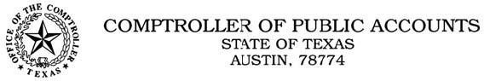

WIRING INSTRUCTIONS FOR COMPTROLLER FED ACCOUNT ROUTING NUMBER: 114900164
FED ACCOUNT NAME: TX COMP AUSTIN
ADDRESS: 208 E. 10th STREET
AUSTIN, TX 78701-2436

ACCOUNT NUMBER: 463600701
ACCOUNT NAME: CPA / TEXAS EDUCATION AGENCY REFERENCE: NAME OF DISTRICT
ATTENTION: TEA FSP Refund/FS1 Fee Code

Be sure to indicate TEA, or funds may be sent to another state agency. If you have any banking questions, please contact Patricia Vela at 512-463-2227.

If you have questions specific to the refund payment, please contact sfinance@tea.texas.gov or 512.463.9238.

