1) Purpose and Structure of Math Innovation Zones

1.1 Vision
The Texas Education Agency seeks to support districts and open-enrollment charter schools in the creation of sustainable blended learning programs that are aligned with the Texas Essential Knowledge and Skills (TEKS). The use of blended learning programs across the nation has led to improvements in both student and teacher outcomes, particularly with regard to closing the achievement gap between students. It is the ultimate intention of TEA to support districts and open-enrollment charter schools in the implementation of these programs across multiple contents and grade levels.

Math Innovation Zones will support districts and open-enrollment charter schools in the implementation of quality blended learning programs in math. The Math Innovation Zones program seeks to improve academic outcomes in math in Pre-Kindergarten(Pre-K) through 8th Grade to ultimately increase 8th grade Algebra I preparedness and participation. Multiple research studies have concluded that students completing Algebra I in 8th grade are more likely than their peers to obtain a secondary degree after high school graduation. The opportunity to dramatically impact the life trajectory of students with a focus on 8th grade Algebra I has established the foundation of Math Innovation Zones.

1.2 Pre-Kindergarten/Kindergarten through 8th Grade Feeder Pattern
To scale the changes necessary to promote student participation and achievement in Algebra I in 8th grade and beyond, TEA is seeking campuses that share a feeder pattern to participate as a Math Innovation Zone bundle. The goal is to launch Math Innovation Zones across all eligible grades in the feeder pattern by Year 4.

In the pilot phase of Math Innovation Zones, TEA will target feeder patterns beginning in either Pre-Kindergarten or Kindergarten (K) and extending through 8th grade. Although a Pre-Kindergarten through 8th grade feeder pattern is preferred, a district or open-enrollment charter schools may exclude Pre-K if its Math Innovation Zones Pilot Grant competitive letter of interest and supporting documentation includes a strong justification outlining how the district or open-enrollment charter schools can be more effective starting with K.

Each proposed feeder pattern will launch Math Innovation Zones at Pre-K or K, 3rd Grade, and 6th Grade in year 1. Respondents to this request for Letters of Interest are applying to implement Math Innovation Zones in each of these three grades. The proposed feeder pattern will then expand to new grades each year until a full Pre-K or K through 8th grade Math Innovation Zones is in place. The below graphic illustrates the growth pattern of Math Innovation Zones.

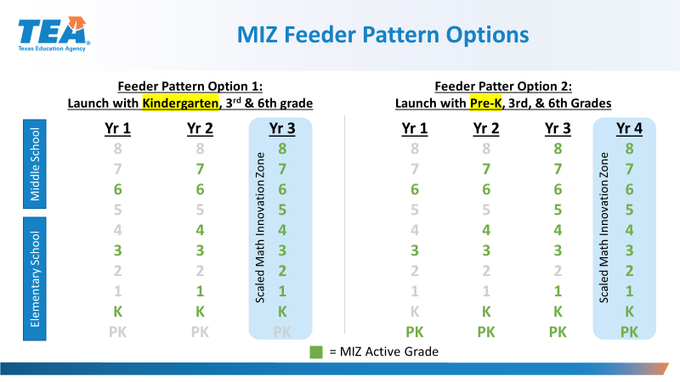

In the unlikely but possible event that a district or open enrollment charter school chooses a feeder pattern approach that is different than the previously described feeder pattern, the district or charter school should justify the approach in the Letter of Interest.

1.3 Stages and Requirements of Math Innovation Zones

Phase 0: Criteria for Math Innovation Zones Pilot Grants
Math Innovation Zone Pilot Grants to be awarded will include up to 5 Math Innovation Zone Pilot Grants between $250,000 and $500,000 and Round 2 Grants for both pilot and exploratory sites of up to $100,000 based on the fulfillment of the Fidelity of Implementation metrics of Math Innovation Zones. To be eligible for either of these grants, a district or open-enrollment charter schools must meet the following criteria:

- Current Blended Learning Outcomes: Submission of evidence of successful outcomes with blended learning within the district or open-enrollment charter schools (not necessarily in the proposed Math Innovation Zone), in at least one full grade, within one school in any subject. This evidence must be student outcomes data (STAAR results, formative assessment results, results specific to the online curriculum program, etc…) relevant to the blended learning program.
  - In lieu of submitting current blended learning outcomes within the district or open-enrollment charter schools, rural districts may submit the current blended learning outcomes of a nearby district or open-enrollment charter school. If choosing this option, the proposing district should submit a plan to collaborate with the neighboring district or charter school, describe the anticipated benefits of the collaboration, and provide a written commitment from the neighboring district charter school to host the proposing district and share best practices.

- Feeder Pattern: Use of funds to support the expansion of blended learning programs across a full Pre-K – 8th grade feeder pattern within four years.
  - Districts and open-enrollment charter schools should list the proposed feeder pattern to be included in the proposed Math Innovation Zone, with a rationale as to why each school is included, as a part of the Letter of Interest (Attachment 2A).
  - Feeder patterns may be within one school (a Pre-K through 8th grade campus, for example) or across multiple schools (2 separate Kindergarten through 5th grade campuses that feed into 1 Middle School campus).
  - If the feeder pattern includes multiple lower grade schools, at least 10% of the students currently enrolled in the upper grade school must have matriculated from the lower grade school proposed in the Letter of Interest.
  - There is no maximum number of feeder schools eligible for proposed Math Innovation Zones, but all schools included in a proposed Math Innovation Zone must adhere to the Fidelity of Implementation requirements for the proposed Math Innovation Zone to be designated as a Math Innovation Zone and eligible for Round 2 grants.
  - If the feeder pattern proposed by the district or open-enrollment charter schools includes lower grade schools that do not offer Pre-K, the district or open-enrollment charter schools may choose to partner with Pre-K programs that feed into the lower grade schools. Although the inclusion of Pre-K in the launch plan is preferred, districts and open-enrollment charter schools may also choose to exclude Pre-K but must provide strong justification outlining how the district or open-enrollment charter schools can be effective beginning with Kindergarten for the intended Math Innovation Zone.
  - Although school districts and open-enrollment charter schools may apply for up to three separate feeder patterns, TEA may award all, some, or none of the proposed feeder patterns proposed for Math Innovation Zones.

- Performance Results and Economic Indicators: TEA will prioritize campuses where at least 75% of students are Approaching Grade Level or Above on 3rd – 8th grade STAAR results during the past 2 years in the average of all subjects and grade levels. TEA will also prioritize campuses serving a high number of students eligible to receive free or reduced-price meals under the National School Lunch and Child Nutrition Program for Math Innovation Zones. Districts and open-enrollment charter schools should include campus level math scores in their competitive letter of interest and supporting documentation.

- Dedicated Project Manager: Districts and open-enrollment charter schools awarded as Math Innovation Zones must designate and provide a district-level project manager who will be available to dedicate at least 50 percent of his/her time to implementing the Math Innovation Zone plan, beginning in the early summer of 2018. This person should be identified and described in the Letter of Interest as requested in the attachments to this document.

Phase 1: Provisional Math Innovation Zone
From the response to this request for Letters of Interest, TEA will select Pilot Grantees and Exploratory Districts and Charters to become Provisional Math Innovation Zones based on the quality of letters of interest submitted as related to the published LOI criteria (Attachment 2). Once a district or open-enrollment charter schools becomes a Provisional Math Innovation Zone, it must meet two distinct categories of Fidelity of Implementation metrics to become a Designated Math Innovation Zone as outlined below in order to be eligible for Round 2 Math Innovation Zone Grants.

  - Fidelity of Planning Requirements – Districts and charter schools must effectively meet a distinct set of planning criteria to demonstrate readiness to implement blended learning in schools. Fidelity of Planning (FOP) is assessed at the end of the summer, at multiple checkpoints throughout the academic year, and upon completion of the indicated plans.
  - Fidelity of Execution Requirements – Districts and charter schools must effectively meet a set of execution requirements to demonstrate effective implementation of Math Innovation Zones. Fidelity of Execution (FOE) is assessed every six weeks throughout the academic year.

Fidelity of Implementation Requirements are further described below.

Phase 2: Designated Math Innovation Zone
TEA will evaluate Provisional Math Innovation Zones at key points in time prior to and throughout the academic year. Upon the conclusion of the academic year, if a district or open-enrollment charter schools has met both the Fidelity of Planning and the Fidelity of Execution requirements, it becomes a Designated Math Innovation Zone. Fulfillment of both Fidelity of Planning and Fidelity of Execution requirements are necessary for continued grant opportunities and recognition as a Math Innovation Zone.

1.4 Math Innovation Zone Technical Assistance Network
All district or open-enrollment charter school selected as grantees will gain access to the Math Innovation Zone Technical Assistance Network to purposefully expand strong blended learning programs across a Pre-K or K through 8th grade feeder pattern of schools. The Technical Assistance Network (TAN) is in the process of being established through a Request For Qualifications resulting in a State Approved Technical Assistance Vendor List.

The Math Innovation Zones Technical Assistance Network will assist districts and charter schools with:

Support 1: Blended Learning Design and Implementation Support to create a blended learning strategy that aligns with the district or charter vision and accommodates for unique district or charter network circumstances (required support)

Support 2: Budgeting and Financial Planning Support specifically related to the financial implications and sustainability of a blended learning program. (eligible for waiver)

Support 3: Professional Development Support for district and school staff involved in implementation and sustained execution of blended learning programs (eligible for waiver)

Support 4: Technology Infrastructure Support to ensure districts and schools have the baseline technology requirements to successfully implement blended learning programs (eligible for waiver)

Support 5: Rostering Support & Data Monitoring to provide districts and charter schools with single sign on, rostering support and the ability to track real-time progress towards identified goals (eligible for waiver)

It is the responsibility of the participating district or open-enrollment charter school to ensure that all technical assistance providers obtain criminal background checks, if necessary.

Technical Assistance Network Requirements
All recipients of Math Innovation Zones Pilot Grants will be required to use a vendor for Blended Learning Design and Implementation Support from the State Approved Vendors List. Although it is highly recommended to use the Technical Assistance Network for all supports, Math Innovation Zones Pilot Grant recipients may either use the services of a state approved technical assistance vendor OR receive a waiver for this requirement from TEA. There are two main reasons that TEA would approve the request to waive the requirement to use the Technical Assistance Network for all supports with the exception of Design and Implementation Support.

- District currently uses the services of a non-state approved vendor with a track record of strong results that can be demonstrated to TEA
- District currently employs an internal expert who is fully equipped to perform the support and has been trained by demonstrated experts

All waivers will be granted or denied at the discretion of the Texas Education Agency and all Fidelity of Planning deliverables will be assessed using the same rigorous criteria, even if a waiver for support is granted.

An excerpt from the Request For Qualifications for the Technical Assistance Vendors for Math Innovation Zones is included in Attachment 3.

2. Math Innovation Zone Grant Opportunities

2.1 Initial Grant Opportunities
As a result of this request for Letters of Interest, TEA will award two types of Math Innovation Zone distinctions:

- Math Innovation Zones Pilot Grants - Up to five districts and charter schools will receive Pilot grants between $250,000 and $500,000. Grantees will be expected to meet Fidelity of Implementation requirements and scale the program across the full feeder pattern in four years. Pilot Grant recipients will also be eligible for Round 2 grants based on fulfillment of Fidelity of Implementation requirements.
- Exploratory Math Innovation Zones- Additional districts and charter schools will be granted access as an Exploratory Math Innovation Zone. In addition to having access to negotiated technical assistance rates and the Math Innovation Zones learning community, these districts and charter schools will also be eligible for Round 2 grants of up to $100,000 based fulfillment of the Fidelity of Implementation requirements. These districts and charter schools show promise and will focus on refining their plans to prepare for future implementation when ready.

2.2 Round 2 Grants
Both Pilot Math Innovation Zones and Exploratory Math Innovation Zones will be eligible for Round 2 grants of up to $100,000. These awards will be determined at the end of the 2018-2019 academic year and will be based on fulfilling the Fidelity of Implementation metric requirements.

All grantees may use these funds during the summer of 2018 and the academic school year of 2018-19. Round 2 funds will be used for the 2019-2020 school year.

The above information is summarized in the charts below.

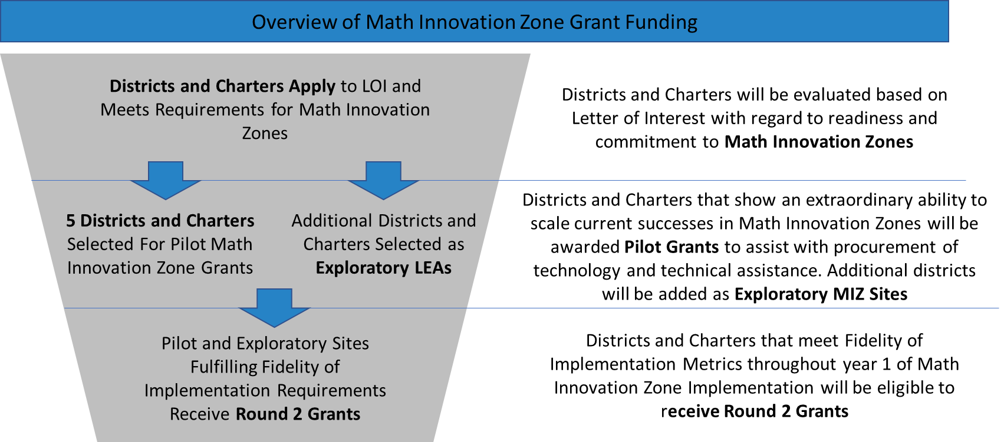

Benefits Overview of Math Innovation Zones for Pilot Grant and Exploratory Districts and Charters

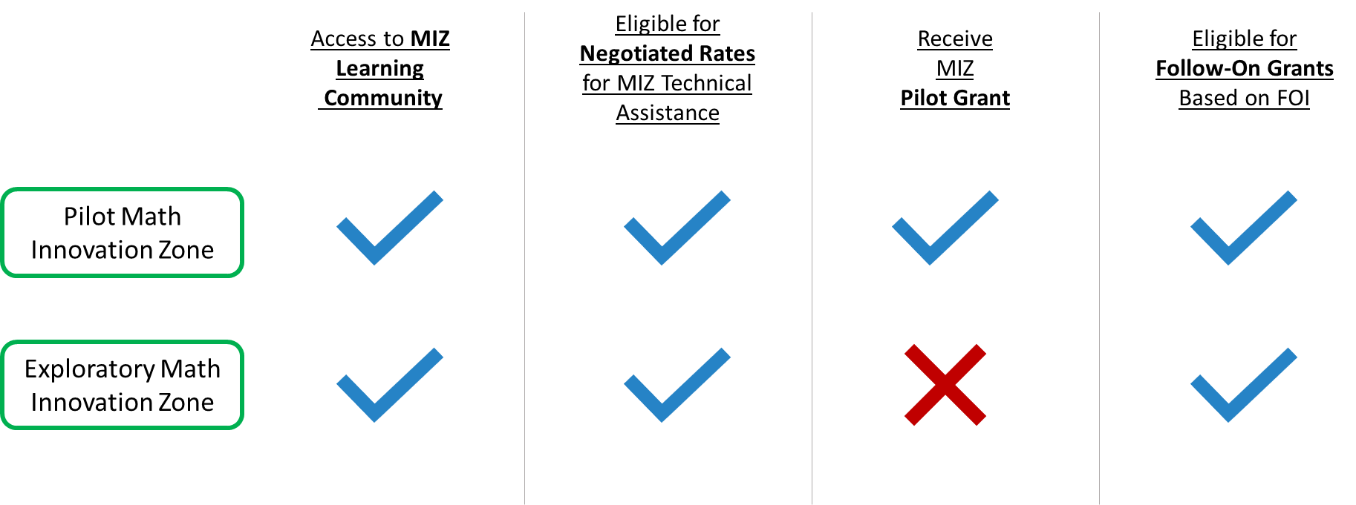

2.3 Use of Funds
Through Pilot Grants and Round 2 Grants, districts and charter schools may use funds to pay for any expenses related to the implementation of Math Innovation Zones in the awarded grades of the awarded feeder patterns. Funds must be used towards an expense in service of the Fidelity of Planning or Fidelity of Execution criteria. Districts and charter schools may use these funds during the summer of 2018 and the academic school year of 2018-19.

Funds distributed as a result of this request for Letters of Interest may be used to purchase:
- Hardware
- Infrastructure
- Software
- Technical Assistance
- Personnel

Further examples of use of funds include:

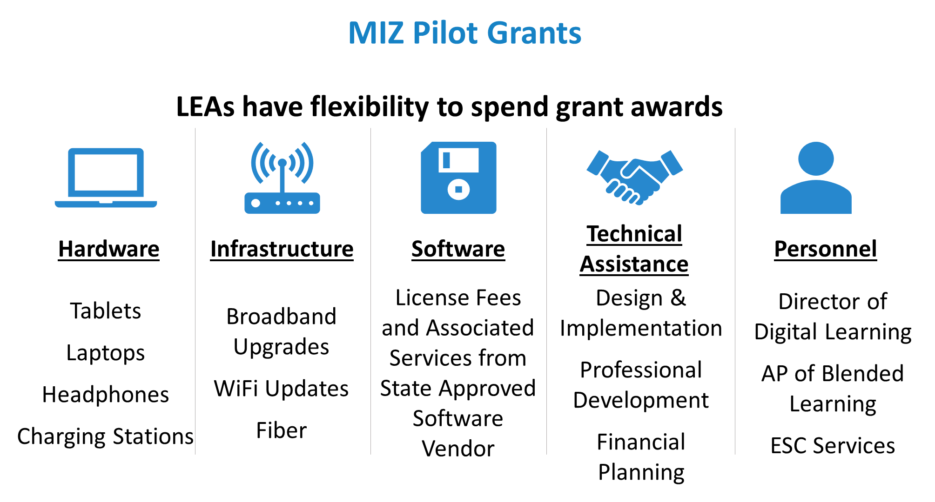

2.3.1 Leveraging Educational Service Centers
If a district chooses, it may use funds associated with the Letter of Interest to outsource components of the program including, but not limited to, the fiscal management (contracting with vendors, submitting invoices, fulfilling reporting requirements with TEA) of Math Innovation Zones with an Education Service Center(ESC). This may be particularly beneficial for districts that prefer to focus on the programming component of Math Innovation Zones. If a district chooses to use an Educational Service Center in the completion of a Fidelity of Planning deliverable, the district must abide by the waiver requirements as described in section 1.4.

3. Fidelity of Implementation Requirements for Math Innovation Zones

3.1 Overview of Fidelity of Implementation

Implementing Math Innovation Zones with a high degree of fidelity is critical to the goal of improving Algebra I readiness and participation in 8th grade. Through monitoring Fidelity of Implementation, TEA will be able to both sufficiently support districts and charter schools as well as evaluate the components of Math Innovation Zones.

To maintain positive standing as a Provisional and/or Designated Math Innovation Zone and to be eligible for Round 2 grants, campuses must meet minimum Fidelity of Implementation requirements to maintain status as a Math Innovation Zone. Fidelity of Implementation is assessed in both planning and execution of Math Innovation Zones. Fidelity of Planning (FOP) requirements are designed to ensure a comprehensive design and implementation strategy is present, providing a successful foundation for Math Innovation Zones. Fidelity of Execution (FOE) requirements are designed to ensure that the program is being executed as intended at the classroom, school, and district or network levels.

Full Fidelity of Implementation requirements for the Math Innovation Zone designation are as follows:

FOI Type | Bucket | # | Sub-Category | Assessment of Fidelity
Fidelity of Planning | VISION & STRATEGY | 1 | District Commitment | Assessed in LOI
 |  | 2 | School Commitment | Assessed in LOI
 | PLANNING | 3 | Design and Implementation Plan | FOP Req 1: Blended Learning Program Design and Plan*
 |  | 4 | Budget and Financial Planning | FOP Req 2: District Financial Plan
 |  | 5 | Professional Development Plan | FOP Req 3: PD Plan and Tools to Evaluate Proficiency
 | TECHNOLOGY | 6 | Software | FOP Req 4: Use of State Approved Software Vendor *
 |  | 7 | Infrastructure | FOP Req 5: Plan for Sufficient Infrastructure
Fidelity of Execution | CONTINUOUS DEVELOPMENT | 8 | Data Driven Instruction | FOE Req 1: Formative Assessment & Data Analysis
 |  | 9 | Ongoing Capacity Building | FOE Req 2: Meaningful Learning Experiences
 | EXECUTION METRICS | 10 | Teacher Usage | FOE Req 3: Active Teacher Usage
 |  | 11 | Student Progress | FOE Req 4: Student Progress Towards Learning Goals
*As explained in section 1.4, the use of a State Approved Design and Implementation Vendor and Software Vendor are required to fulfill Fidelity of Planning Requirements.

3.2 Fidelity of Planning Requirements

FOP Requirement #1: Design and Implementation Deliverables
Districts and charter schools will be required to complete the following Design and Implementation deliverable using a state approved vendor from the Math Innovation Zones Technical Assistance Network. Districts and charter schools must obtain TEA approval of plan to satisfy Fidelity of Planning Requirements.

- Blended Learning Program Design and Plan: Drive school or district-specific program design to determine the appropriate blended learning strategy for the unique school context. This should include a launch plan for blended learning in new grade levels over time, the identification of the appropriate instructional model for each classroom, assessment and selection of approved blended learning vendor, human capital considerations, and plan for data driven decision making across the campus.

FOP Requirement #2: Budget and Financial Planning Deliverables
Districts and charter schools will be required to complete the following Budget and Financial Planning deliverable. Districts and charter schools must obtain TEA approval of plan to satisfy Fidelity of Planning Requirements.

- District Financial Plan: Assist school and district finance teams in the development of a sustainable long-term budget that accounts for blended learning specific considerations including staffing ratios, instructional materials, and ongoing blended learning specific costs. Plan should include one-time and recurring funding sources and program expenses, including the identification of alternative sources of operating funds. The plan should include a list of inputs and assumptions that are approved by the full blended learning team, including district staff - across multiple functions including finance, curriculum, and teacher support - school leadership, and teachers.

FOP Requirement #3: Professional Development Deliverables
Districts and charter schools will be required to complete the following Professional Development deliverables. Districts and charter schools must obtain TEA approval of plan to satisfy Fidelity of Planning Requirements.

- Professional Development Plan: Work with districts to set district training goals, identify roles and responsibilities of teachers and coaches, proposed professional development delivery model, create training timeline, and design coaching feedback system.
- Tools to Evaluate Participant Proficiency: Build tools including rubrics, templates, and other resources, to assess blended learning readiness, development, and proficiency at the campus and district level.
- Tools to Evaluate Professional Development Efficacy: Create resources to evaluate efficacy of professional development including surveys for teachers, administrators, and district officials. Provide alternative means for documenting and sharing district successes and challenges.

As part of the requirements related to professional development, districts and charter schools awarded with Math Innovation Zone grants may be required to:
- Participate in up to 5 Math Innovation Zone cohort professional development opportunities and/or conferences involving the project manager or other district or open-enrollment charter schools leader(s) of the initiative
- Host TEA and other Math Innovation Zone cohort members for occasional site visits to learn from implementation across the state
- Share relevant data from the Math Innovation Zone with TEA, as required by Texas Education Code Section 28.020
Districts and charter schools may use funds from Math Innovation Zone grants to assist with expenses related to these requirements.

FOP Requirement #4: Use of State Approved Online Curriculum Vendor
Districts and open-enrollment charter schools participating in Math Innovation Zones will be required to select a math online curriculum program from the Math Innovation Zones State Approved Online Curriculum Vendors List. State Approved Online Curriculum Vendors have been evaluated and chosen based on the following criteria:

- Demonstrated impact on student achievement
- Product alignment with TEKS
- Service plan for implementation within district or open-enrollment charter schools
- Strong metrics to assess fidelity of implementation.

The four State Approved Software Vendors for online curriculum are:

- Reasoning Mind
- ST Math (from MIND Research)
- IXL Math
- Imagine Math (formerly known as Think Through Math)

Participating districts and open enrollment charter schools must implement the selected software program in all classrooms of a chosen grade level at a single school. If a district or charter school chooses, it may select different programs to be implemented at different schools or grade levels as long as all participating classrooms within a grade level are using the same software program.

FOP Requirement #5: Complete Technology Infrastructure Deliverables
Districts and charter schools will be required to complete the following Technology Infrastructure deliverables. Districts and charter schools must obtain TEA Approval of plan to satisfy Fidelity of Planning Requirements.

- Infrastructure Improvement Plan: Develop a clear plan and timeline to create a robust infrastructure that supports the long-term vision of blended learning within district or open-enrollment charter schools and assist in executing plan.
- Technical Support Capacity Building Plan: Create strategy for capacity development within district to ensure high quality ongoing technical support and information technology function across the district or charter schools.

3.3 Fidelity of Execution Requirements

In addition to Fidelity of Planning, districts and charter schools will be required to exhibit evidence of ongoing progress and program development with regard to Fidelity of Execution Metrics as required by Math Innovation Zones.

FOE Requirement #1: Formative Assessment & Data Analysis
During implementation of Math Innovation Zones, TEA will assess the ongoing level of Data Driven Instruction. Although the type of formative assessment may vary, TEA seeks evidence of the use of formative assessments, analysis of data, and improvement of practice regarding Math Innovation Zones. Districts and charter schools will be required to complete the following Fidelity of Execution requirements and share relevant data with TEA:

- Administer Quarterly Formative Assessments: All Math Innovation Zone classrooms launching blended learning programs must administer formative assessments on a quarterly (Fall, Winter, Spring) basis and send results to TEA.
- Weekly PLC Meetings: All teachers in grade level(s) participating in Math Innovation Zones must meet once weekly in Professional Learning Communities (PLCs) to analyze relevant data and plan based on data analysis; TEA may require the submission of an agenda or notes from meeting.
- Quarterly Step Back: All teachers in grade level(s) participating in Math Innovation Zones must participate in quarterly (or other cadence as required by the formative assessment) data step backs to assess progress towards growth goals and plan based on their analysis; TEA may require the submission of an agenda or notes from the step back or attend the step back meeting.

FOE Requirement #2: Meaningful Learning Experiences
During implementation of Math Innovation Zones, TEA will assess the level to which districts and charter schools are actively supporting teachers in their own professional development with regard to the Professional Development Plan created in the planning stages. Meaningful Learning Experiences (MLEs) can be a variety of professional development structures including: district or vendor-led classroom observations; 1:1 blended learning coaching sessions; meaningful workshops; and excellent school visits to high quality blended learning programs. Although MLEs may look different across campuses, all MLEs will result in a change in teacher knowledge, skill, and/or mindset. Districts and charter schools will be required to complete the following Fidelity of Execution requirements and share relevant data with TEA:

- Meaningful Learning Experiences: All teachers in grade level(s) participating in Math Innovation Zones must participate in 2 Meaningful Learning Experiences (MLEs) per month for the first three months of the school year and then 1 MLE per month for the following 6 months. TEA reserves the right to reject a learning experience as a fulfillment of FOE requirements due to a gross lack in quality.

FOE Requirement #3: Exhibit Sufficient Teacher Usage
During implementation of Math Innovation Zones, TEA will assess the level to which classroom teachers are interacting with and taking action from the insights delivered by the software platform. As required by Math Innovation Zones, districts and charter schools must share outcomes data from the selected online curriculum program with TEA using whichever data collection mechanism is required by TEA. Although the actual metrics will depend on the chosen state approved online curriculum vendor, metrics may include, but may not be limited to:

- Number of teacher interactions with platform per six weeks
- Average response time to struggling students per six weeks
- Average time spent on software by the teacher per six weeks

FOE Requirement #4: Students Progress Towards Learning Goals
During implementation of Math Innovation Zones, TEA will assess the level to which students are progressing towards the individualized learning goals set forth by the chosen online curriculum program. As required by Math Innovation Zones, districts and charter schools must share outcomes data from the selected online curriculum program with TEA using whichever data collection mechanism required by TEA. Although the actual metrics will depend on the chosen state approved online curriculum vendor, metrics may include:

- Percent of students achieving vendor recommended progress towards goals per six weeks as defined by individual learning plan
- Percent of students accurately completing program-based assessments within two attempts per six weeks

4. Budget and Use of Funds
Through this request for Letters of Interest, TEA will select up to 5 pilot districts and/or open-enrollment charter schools to apply for Pilot Grants for Math Innovation Zones between $250,000 and $500,000. Through this request for Letters of Interest, TEA will also select up to 10 Exploratory Math Innovation Zones to apply for eligibility of Round 2 grants of up to $100,000. Both Pilot Math Innovation Zones and Exploratory Math Innovation Zones are eligible to receive Round 2 grants of up to $100,000 based on fulfilling requirements of the Fidelity of Implementation Metrics. The long-term cost of implementation, however, will not be absorbed by TEA and Math Innovation Zone all grant funding must be exhausted by 8/31/2020.

5. Timeline
This Request for Letters of Interest marks the beginning of the Math Innovation Zones pilot year. Selection of districts and charter schools will be followed by the beginning of technical assistance, followed by ongoing support throughout the spring of 2018 and into the summer and fall. Although the timeline for Math Innovation Zones is subject to change, the anticipated timeline is as follows:

 | Feb | Mar | Apr | May | Jun | July | Aug | Sept | Oct | Nov | Dec | Jan | Feb | Mar | Apr | May
Districts Selected and Grants Awarded
Districts Contract with TAN
Summer FOI Checkpoint
MIZ Pilots Begin
Winter FOI Checkpoint
STAAR Testing
End of Year FOI Checkpoint
Follow-on Grant Awards

6. Closing and Next Steps
Please review and complete Attachments 2A, 2B, and 2C, which serve as the Letter of Interest for Pilot and Round 2 Grants for Math Innovation Zones. Upon completion, submit to specialprojects@tea.texas.gov by April 27th, 2018 at 5pm(CDT).

The subject line should read as follows: MIZ LOI - <INSERT DISTRICT NAME>; Ex. MIZ LOI - TEXAS ISD

TEA will review the letters of interest and select up to 5 districts and/or open-enrollment charter schools to apply for pilot grants. Successful proposers will be contacted regarding timeline, decision points, and next steps.

If any assistance is needed, please contact Andrew Hodge, Director of Math Innovation Zones at andrew.hodge@tea.texas.gov.

