ECOS Approver Training
This document will familiarize you with the roles and responsibilities of being an Educator Certification Online System (ECOS) approver along with the procedural steps in granting access to ECOS applications. The ECOS application is considered as three distinct applications: ECOS for Educators, ECOS for Entities (used by Educator Preparation Programs (EPP) and District users), and the ECOS for Admins Application.
There are two types of approvers in TEAL, Organization Approvers and Service Approvers (also known as Application Approvers).The business area will need to establish both organization approvers and service approvers for all ECOS applications.

Approvers and Requestors Defined
Access requests to all applications in TEAL must be reviewed by at least two approvers. There are three actors involved in each request.
- A Requestor is someone who submits a request for access to an ECOS application in TEAL. A Requestor could be an educator, school administrator, educator preparation program (EPP) staff member, TEA staff person, or any other member of the educational community.

- The Organization Approver provides the first level approval for access requests to applications. It is their responsibility to verify that the Requestor is part of their organization, and that the Requestor should have access to ECOS in the role that is being requested. An organization can have three different types of approvers:
  - Primary Approvers have the principal responsibility for approving requests for their organization. Primary Approvers are the Organization Heads (e.g. district superintendents). There can only be one Primary Approver in an organization.
  - Primary Approvers can set up Alternate Approvers within their organization, who will act on behalf of the Primary Approver to approve access to all applications. There can be more than one Alternate Approver for an organization.
  - Primary Approvers can also delegate their responsibility to Limited Approvers, who will approve requests for access to only specific TEA application(s) for an organization.
Note: Alternate and Limited approvers act on behalf of the Primary Approver to approve access to TEA applications, but they cannot set up other delegate approvers.
- The Service Approvers provide the final approval for access requests to ECOS applications. Service approvers are typically TEA employees with deep understanding of the application and relevant roles and permissions.

A denial from any approver will result in an email notification to the requestor.

One can only be a single type of approver at any given time.

The Approval Process
Access requests to applications in TEAL must be reviewed by at least two approvers. This process is summarized here.

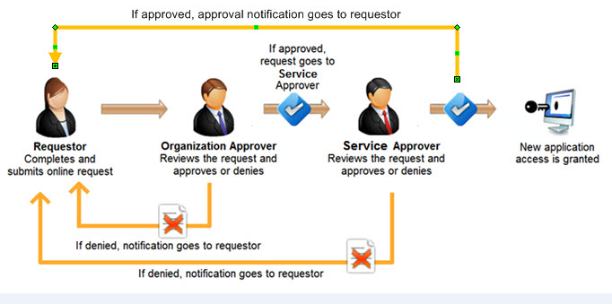

TEAL Activities that Require Approval
- Approval is required to grant user access to the ECOS for Entities and ECOS for Admins applications. Service and Organization approvers must approve or deny ECOS access requests in a timely and appropriate manner.
- Approval is also required to become an approver. Organization Approvers and Service Approvers must be approved by TEA and organization heads.
- Access to ECOS for Admins and ECOS for Entities applications is periodically recertified to verify whether a user's access is still appropriate and valid. Similarly, approvers are also periodically recertified to verify appropriateness and validity of their responsibilities. The recertification process follows a similar process to the approval process when access was originally granted.

Requesting to be an Approver
This section of the document will explain the process and procedural steps necessary to request Approver privileges.
- Once you have created your TEAL identity, login and select Edit My Profile from the Self Service section in the left hand menu.

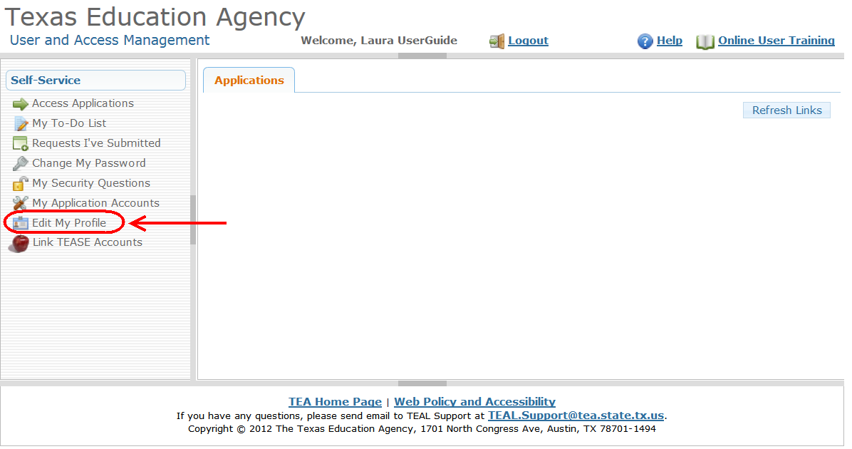

- The Edit My Profile page will appear. Scroll to the bottom and click the Manage Approver Status button.
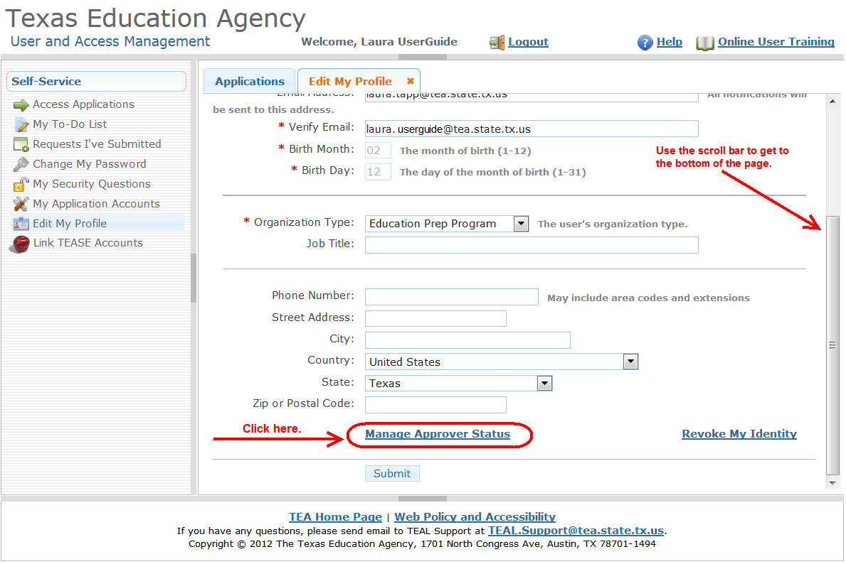

- A message regarding approver responsibilities and a link to online interactive approver training is displayed. Click the Request Approver Status button.

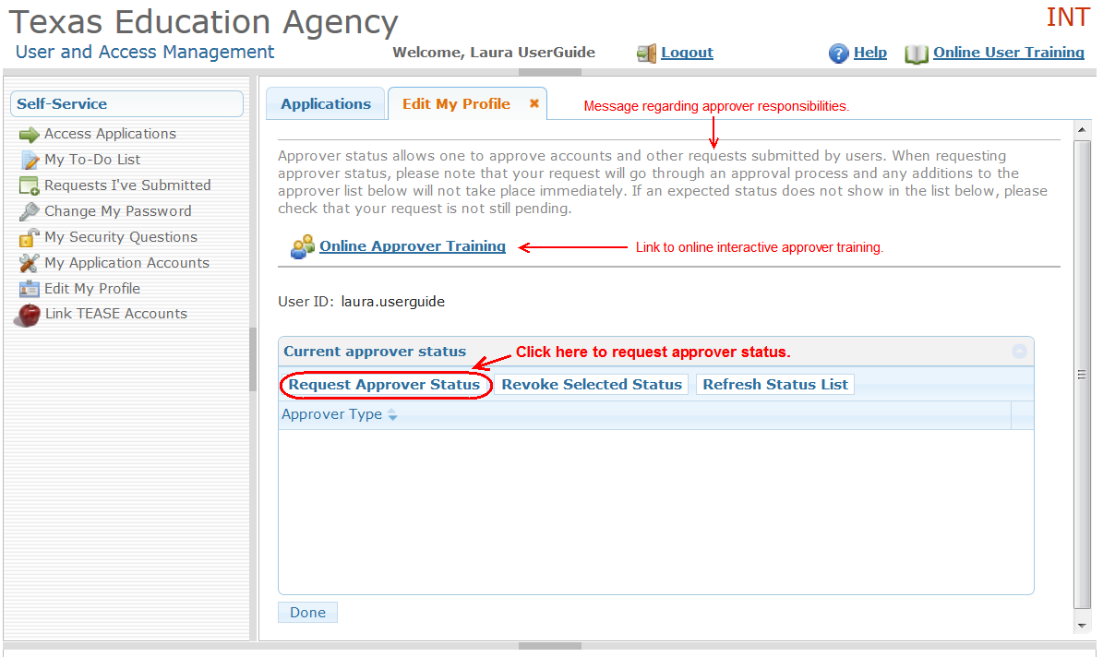

- The Approver Status Details page is displayed. Select the type of approver you want to be in the Approver Type drop down list.
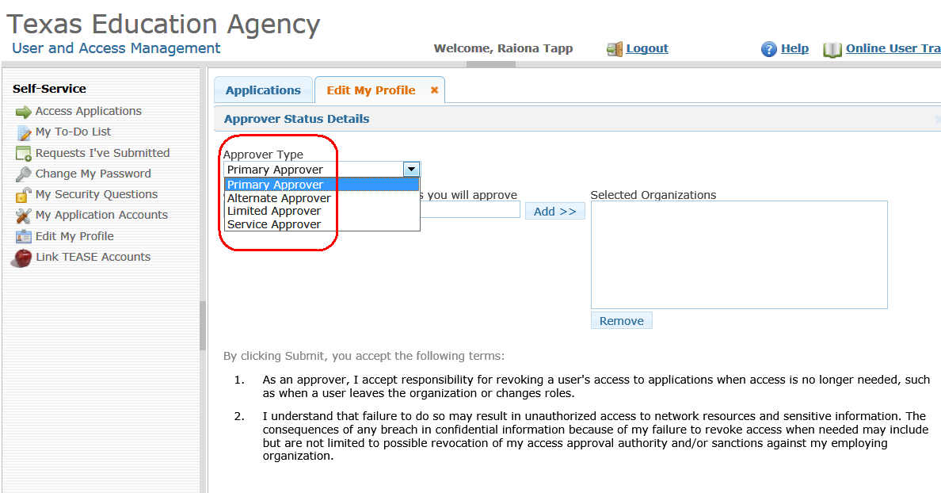

- Next, begin typing either your organization name or numeric ID in the Organizations whose users' requests you will approve field. As you type, matching organizations will appear. Select your organization from the list, then click Add.
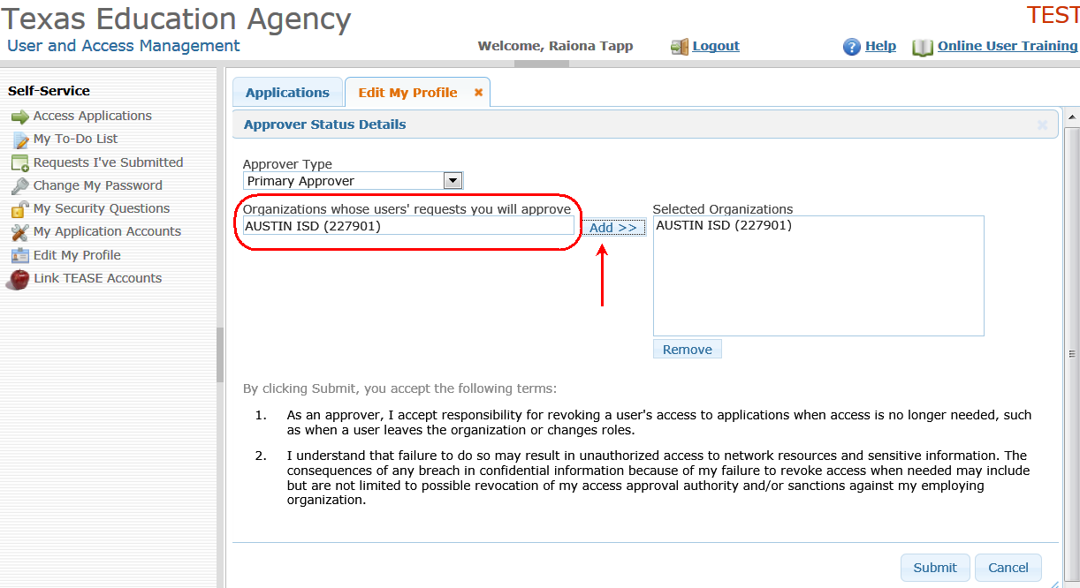

- Scroll to the bottom of the page, read the approver responsibilities, and select the Submit button.
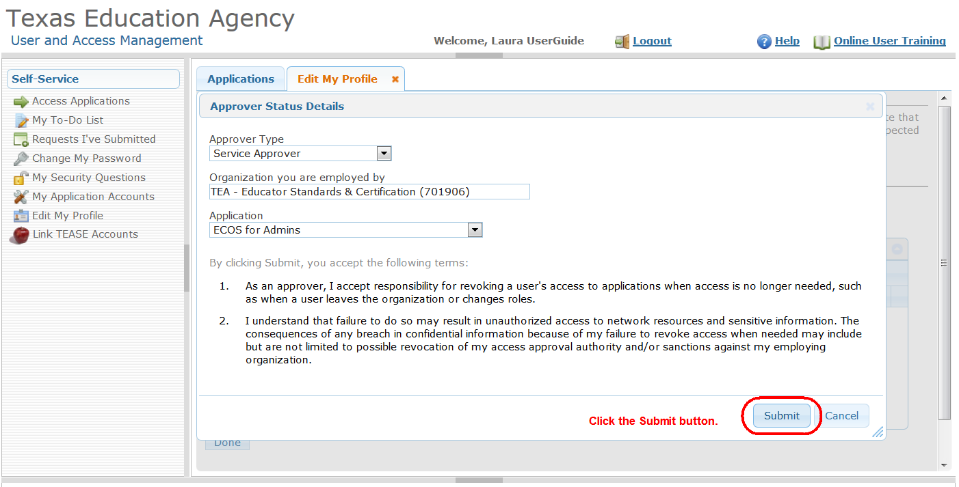

- A message appears indicating your approver request has been successfully submitted. Service approver request requires approval from your organization's Primary Approver within their organization, then approved by the TEA Information Security Officer.

You will receive an email notification once your request has been approved or denied.
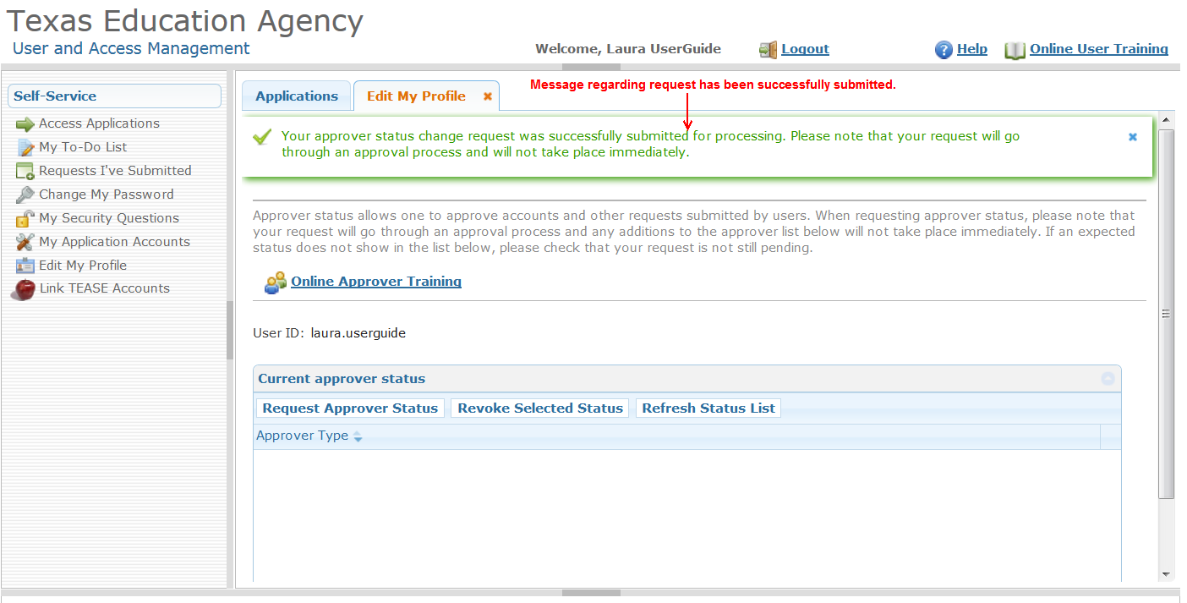

Who grants your Approver responsibilities?
The following is the approval workflow routing for all approver requests. Once a decision has been made on the request, the requestor will be notified by email.
Note: It is not possible to be an organization approver and service approver at the same time. Also, one person cannot be a Primary, Alternate and/or Limited approver for the same organization. Such requests will be denied automatically in TEAL.
Organization Approvers:
- User requests to be Primary Approver > Computer Access (verifies that the requestor is the organization head per the org chart) > TEA Information Security Officer
- User requests to be Alternate Approver > Primary Approver > Computer Access > TEA Information Security Officer
- User requests to be Limited Approver > Primary Approver > TEA Information Security Officer
Service Approvers:
- User requests to be a Service Approver > Primary Org Approver > TEA Information Security Officer

Approver Activities
This section of the document will help you get familiar with the activities that you might have to perform as an approver.
After reviewing this section, you will be able to:
• Approve or reject a request
• Manage other approvers
• Manage others’ accounts
• View request history and status
• Explain the process of periodic recertification of applications and approvers
• Identify the approver recertification policies

6.1 Approving or Rejecting a Request
- As an Approver, you will be notified by email that you have pending activities and you will see a message on your TEAL page. To see your pending activities, either click the link in the "pending activities" message or My To-Do List link in the Self Service section on the left.
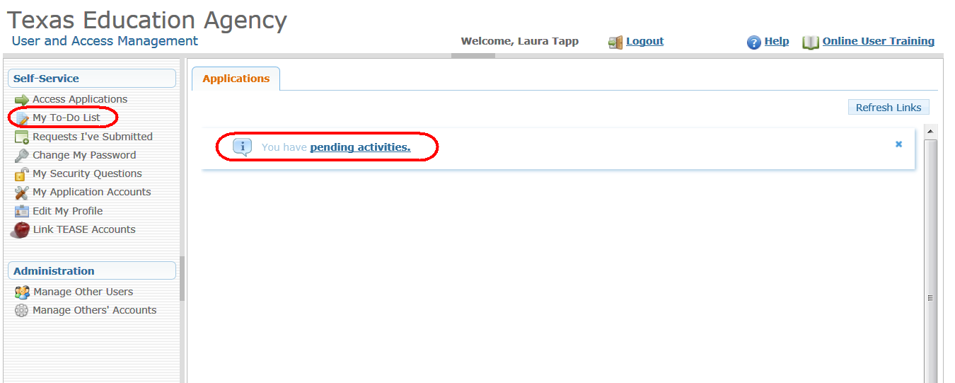

- The My To-Do Items page appears with your pending activities. Click on any activity to see the activity details. The activity details are displayed on the right.
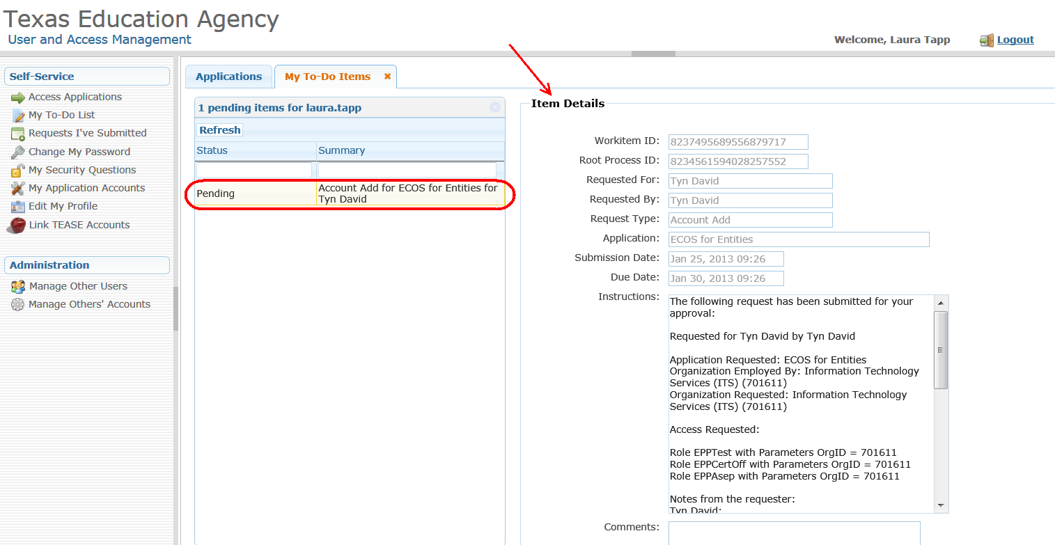

- Scroll to the bottom of the page, enter comments if desired, then click the appropriate button at the bottom of the page to take action on the request.
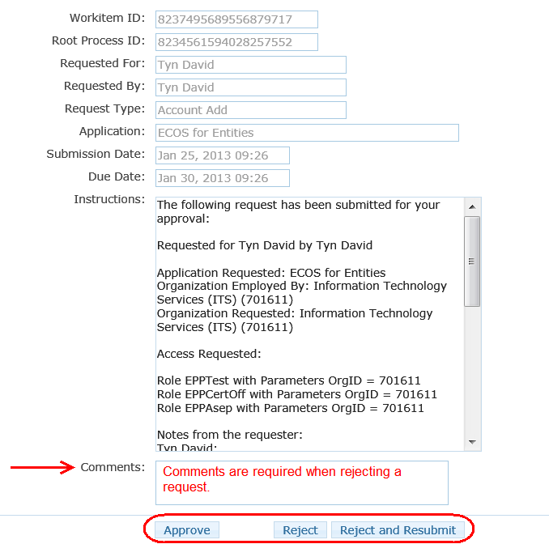
Clicking Approve will move the request forward in the approval process.
Reject will deny and end the request. The requestor will be notified via email.
Reject and Resubmit will reject the request an allow you to change and resubmit it. This option allows you to correct a mistake made in the original request (see the next section for details regarding how to Reject and Resubmit a request)
Please note that TEAL does not validate user names, role(s) requested, or other information on access requests. As an approver, you must use your best judgment before approving requests. If you are unsure or suspect questionable activity, then contact Computer.access@tea.state.tx.us .

- The request status is changed in your Pending Activities. For this example, the request was approved.
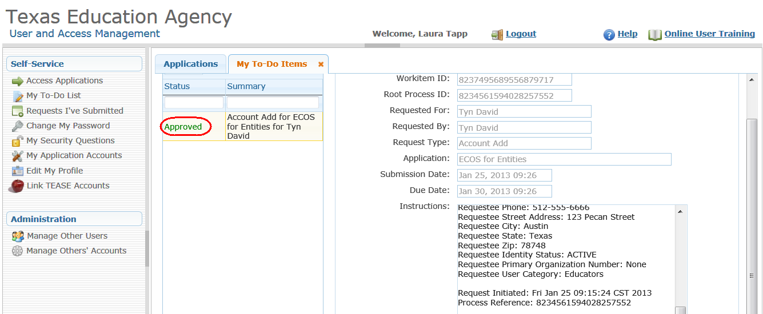

- Once you refresh the Pending Items list, the items you have taken action on will disappear from the list. Items will also be removed if another approver acts on the request, or if the request is not acted on in a timely manner.
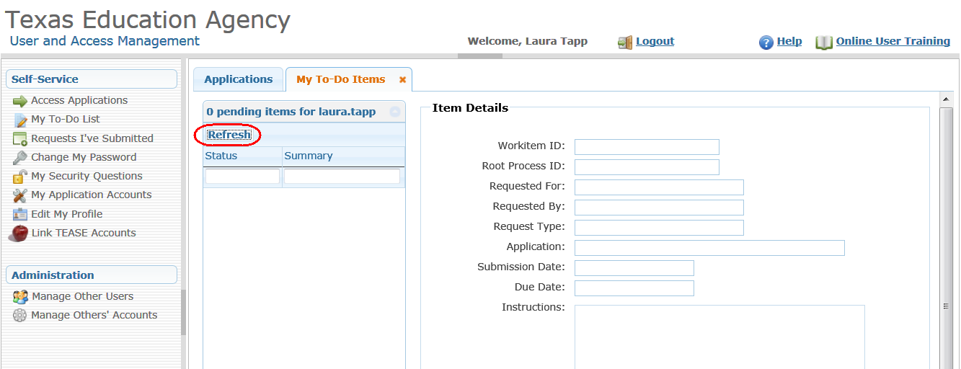

6.2 Reject and Resubmit a Request
Approvers can reject and resubmit a pending request. This action denies the request, allows the approver to make corrections on the requestor's behalf, and resubmit the request. This is helpful if the requestor asked for an incorrect role.
- To reject and resubmit a revised request on the requestor's behalf, first select the request from your queue, enter comments regarding why you are rejecting the request, then select the Reject and Resubmit button at the bottom of the page. Note, the requestor will receive an email indicating that their request has been rejected and the comments entered.

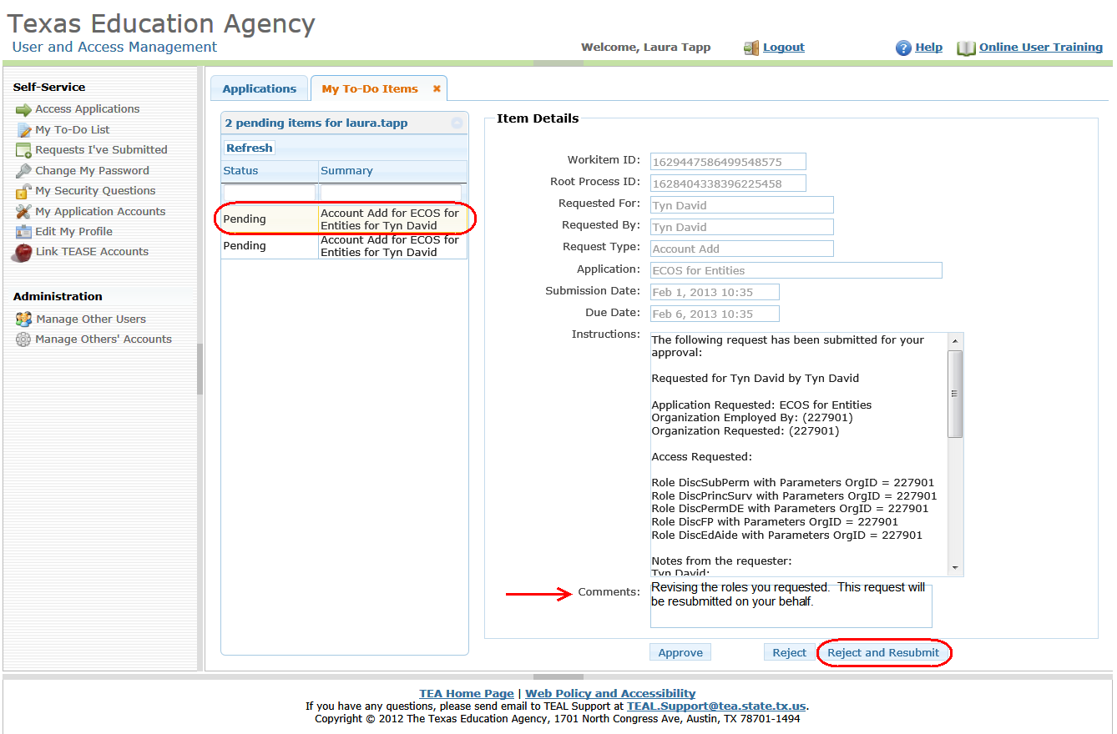

- To resubmit the request, first select it from the list. It will include the requestor's name and the application they are applying for, the roles requested, and their employing organization. For this example, we're going to remove one of the roles the user requested. Select the Remove Selected button.
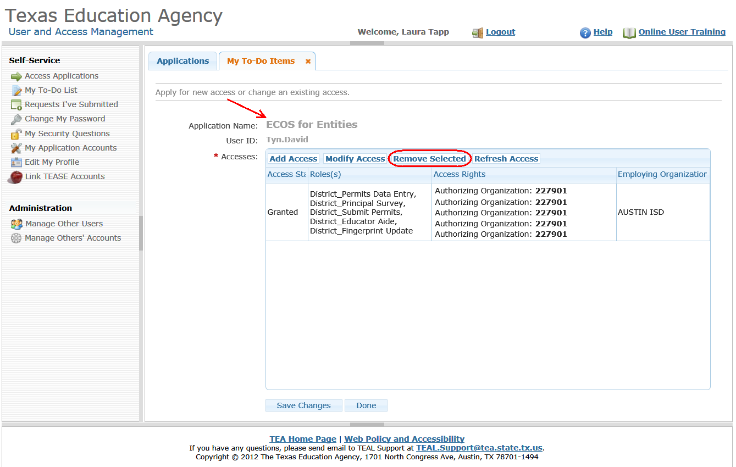

- A new page appears with all the roles the user requested. Select which role(s) you would like to remove from the request, then select the Submit button
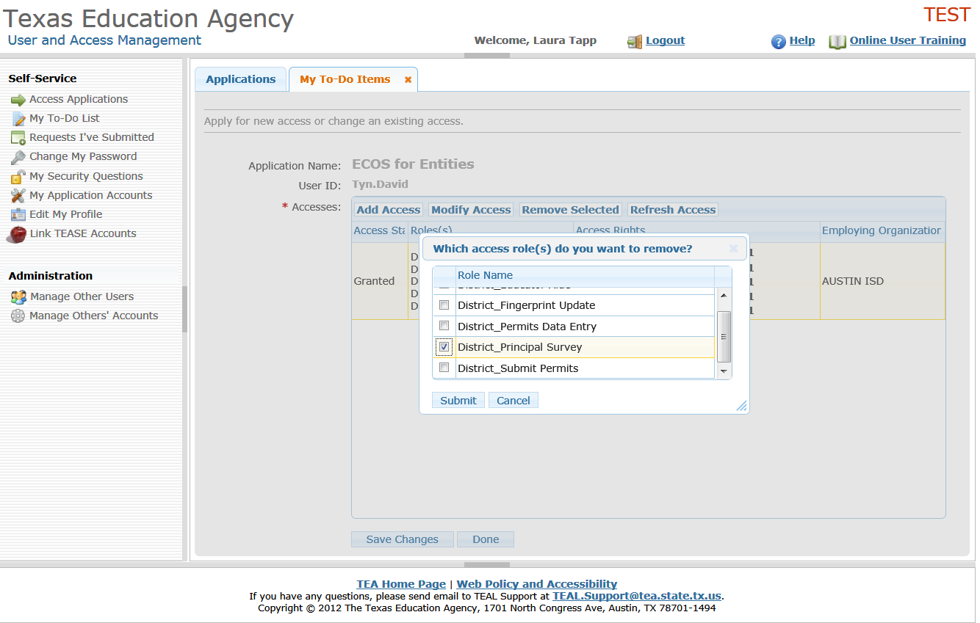

- Confirm that you want to remove the role(s) selected.
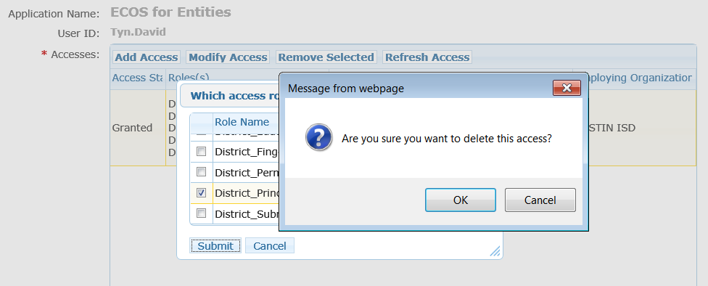

- The roles that you selected for removal now appear with strikethrough the text. Select the Save Changes button at the bottom of the page.
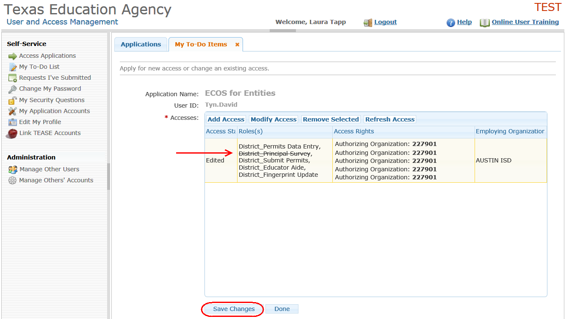

- A message indicating the success of the request revision appears at the top of the page.
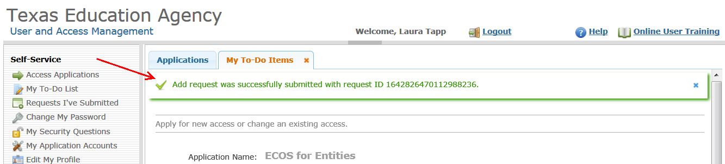

6.3 Manage a User's Access to ECOS
Primary or Alternate Organization Approvers can manage others’ ECOS user accounts within their organization. These approvers can also manage other approver's within their organization.
ECOS Service Approvers can manage all users who have access to the ECOS for Entities and ECOS for Admins applications. For an existing user, both types of approvers can:
- Request new account
  - Search for a user by user name and request access to ECOS on their behalf
- Suspend an existing ECOS account
  - Suspending a user's account will remove the ECOS access from their TEAL jump page.
- Restore a suspended ECOS account, or
  - Restores an account that has been suspended.
- Delete an existing ECOS account
  - Deletes the user's account immediately, and cannot be restored.
This will not impact the user's TEAL identity or access to other TEA applications.

- To manage user accounts for your organization, select Manage Others' Accounts in the left hand menu.

- Next, select one of the filter options in the list, either whether the user is employed by your organization, or authorized to access your organization's data, and click on the Search Accounts button

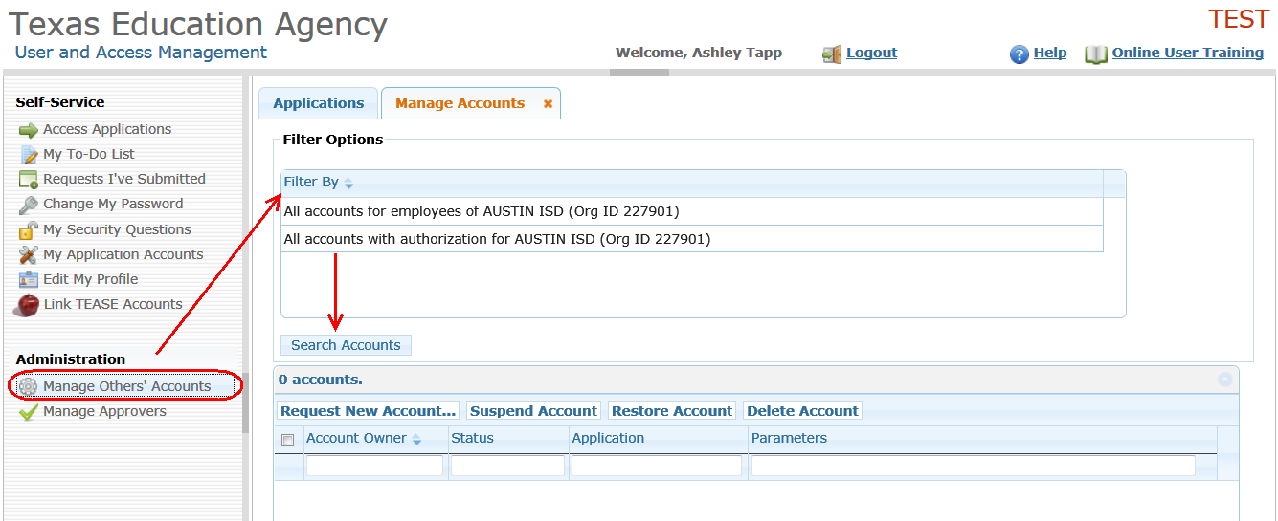

- Next, select which user's access you want to revise and the action to be taken. For this example, the user's account will be suspended. The user will get an email notifying them of the suspension, and when they login to TEAL the next time, the ECOS application will not appear on their TEAL Applications page.

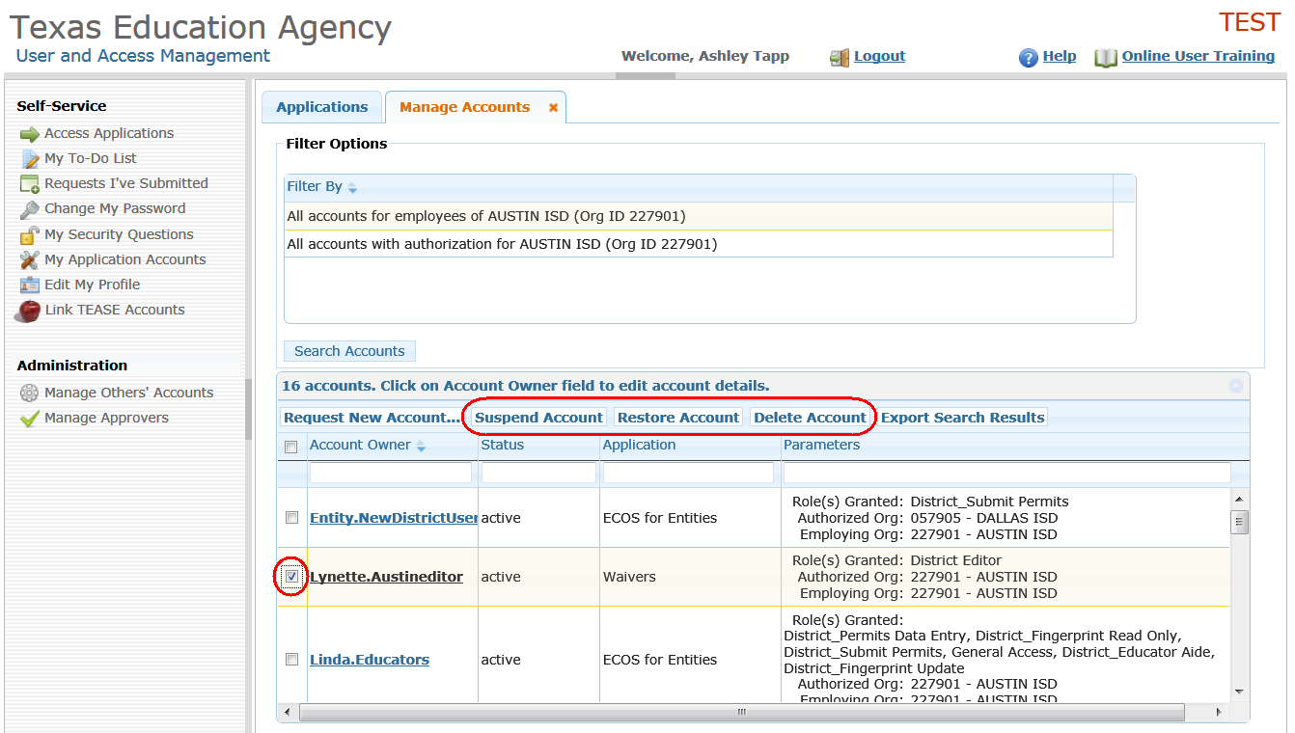

- After processing, TEAL will indicate the new account status.
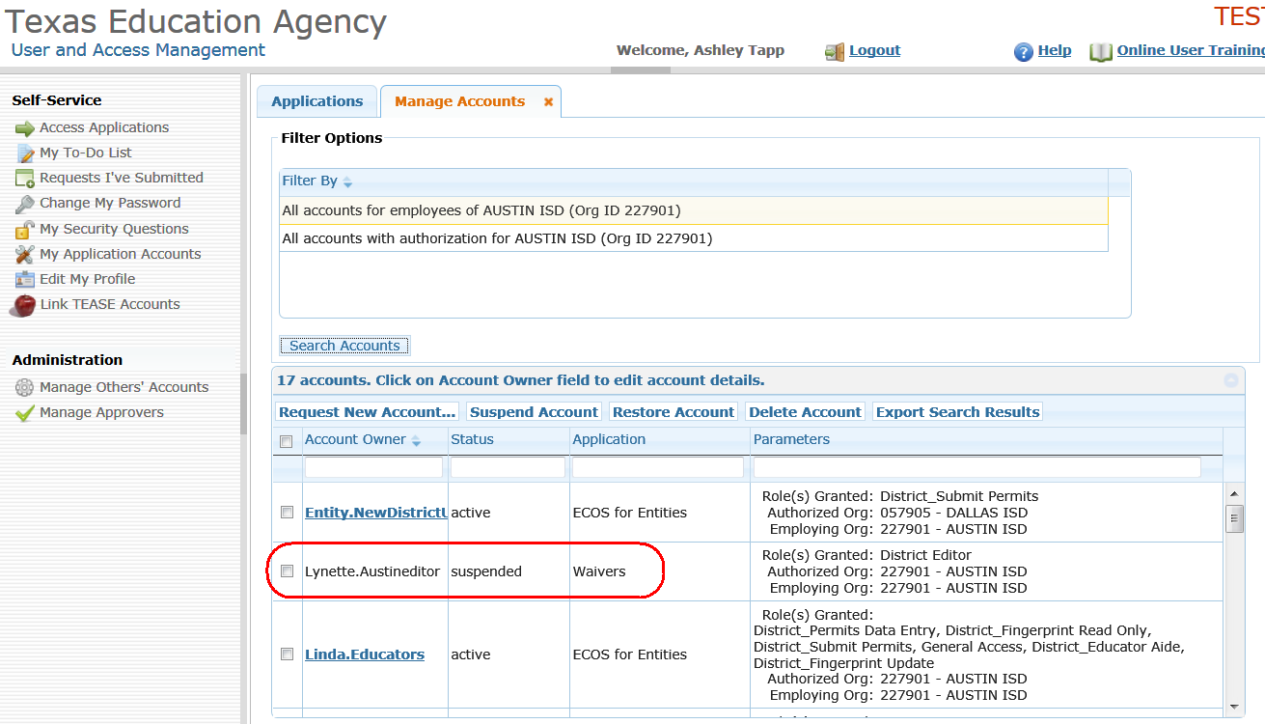

6.4 Recertification of Approvers and User Accounts
Access to the ECOS for Entities and ECOS for Admins applications will be periodically recertified, typically once a year. Permissions to be an approver are also reviewed and recertified. The recertification process is similar to new access requests.
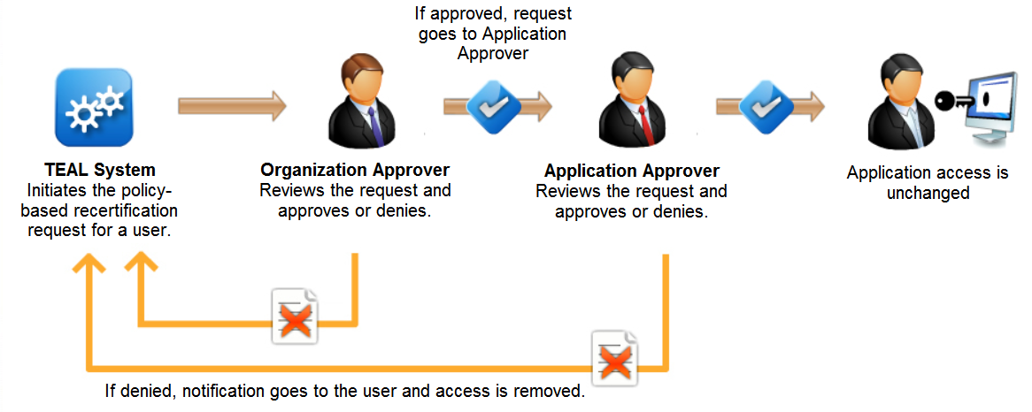

During the recertification process, TEAL automatically sends notifications and approval requests to approvers and application users. Approvers should determine if each user is still employed in their organization and whether the user's job responsibilities require they have the same level of access to the ECOS application.

If an approver marks access as no longer valid or fails to respond within a reasonable amount of time, that user is notified and their access is automatically disabled in TEAL.

6.5 Manage Approvers
Primary organization approvers can manage permissions for all other approvers within their organization. This means they can revoke an approver's authority within their organization.
- Select the Manage Approvers button on the left and side of your TEAL page. Next, select to Search Approvers for all approvers within your organization. TEAL will display all approvers for the selected organization. You will not be able to manage approvers for any organization that you are not a primary approver for.

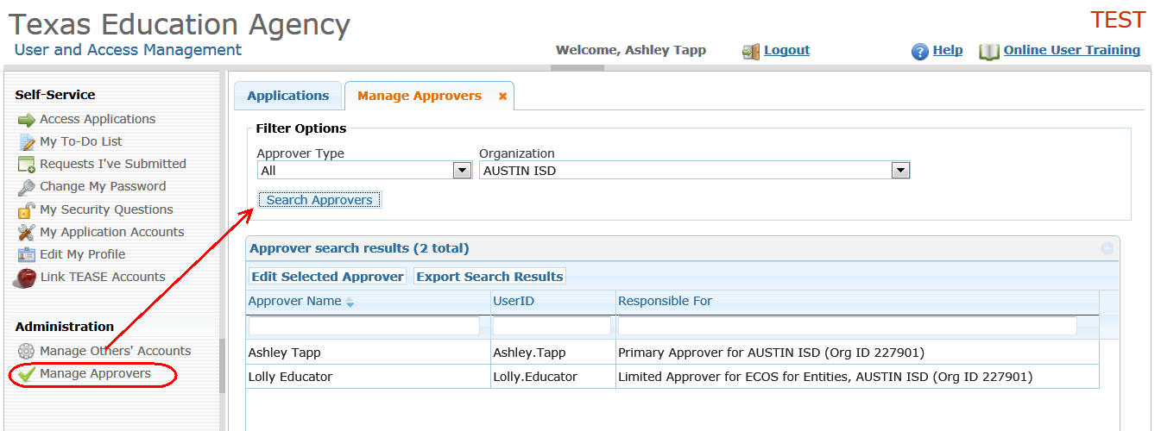

- Next, select an approver from the list, then click the Edit Selected Approver button. For this example, approver Lolly Educator was selected.
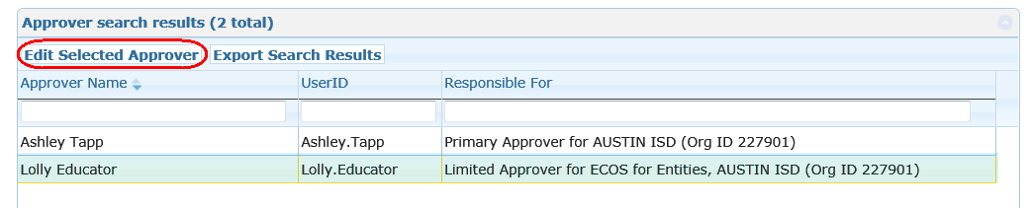

- TEAL displays a page for the primary approver to revoke the selected approver's status.
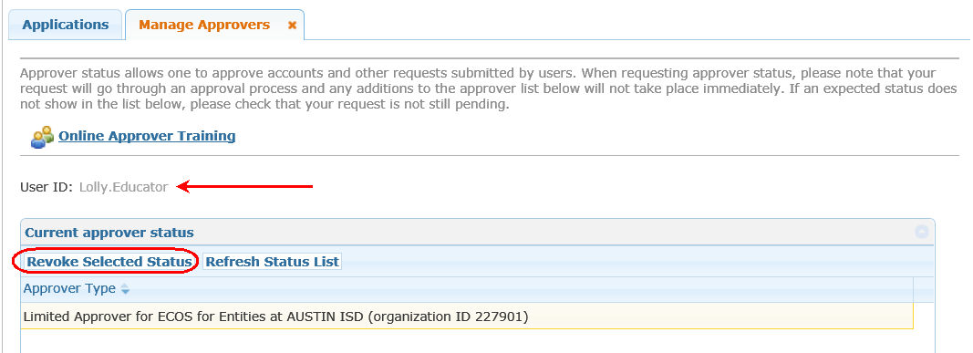

- The primary approver will be prompted to confirm that they want to revoke the approver's status.
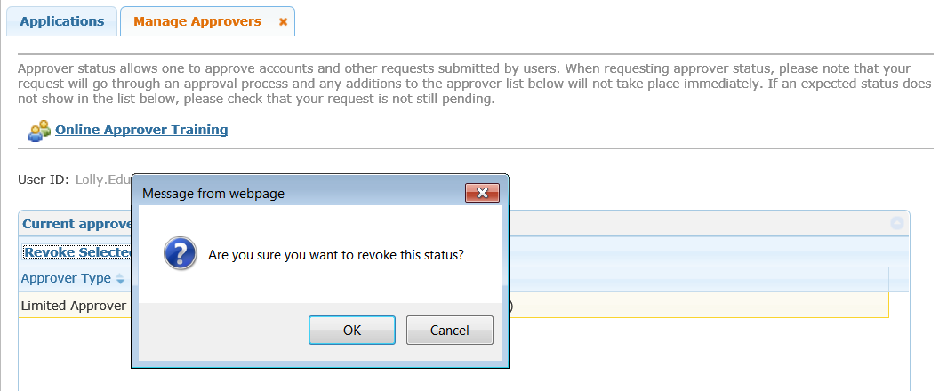

- After confirming to revoke the approver's status, TEAL displays a message. The approver whose status was revoked will be notified by email.

