TEAL User Instructions
TEA Login (TEAL) is an updated, more secure replacement for TEA’s older web access management system, TEASE (TEA Secure Environment). Some TEA applications, like Educator Certification Online System (ECOS), were never part of TEASE, but had a built in security system that is also being replaced by TEAL. TEAL enables you to request secure access to TEA applications and to manage your user account and profile information.
These instructions should familiarize you with basic functions in TEAL.

Glossary
ECOS | The Educator Certification Online System application is considered as three distinct applications: ECOS for Educators, ECOS for Entities (used by Educator Preparation Programs (EPP) and District users), and the ECOS for Admins Application.
ECOS for Educators | The Educator Certification Online System "blue screen" application used by all educators to manage their certifications.
ECOS for Entities | The Educator Certification Online System "green screen" application used by school districts, charter schools, and educator preparation programs.
Entity | An entity is any school district, charter school or educator preparation program.
EPP | Educator Preparation Program
TEAL | TEA Login security application used for identity and access management.

Features of TEAL
TEAL provides access to ECOS applications and will help you to access educator records, school data, and other information that must be kept secure from unauthorized access.

From the login PAGE, you can perform the following functions:
- Self-register for a new TEAL user account
- Request a forgotten password to be reset
- Request and automatically receive a forgotten username

From the main PAGE, you can do the following:
- Request access to TEA applications
- View the status of your requests
- Respond to requests submitted by other users, if you are an approver
- Manage your profile information
- Change your password
- Maintain and change your security questions

Requesting a TEAL New User Account
- The first time you login to ECOS after Feb 28, 2013, you will see a new page that gives you instructions how to get started in TEAL.
- Entity users will see this page:
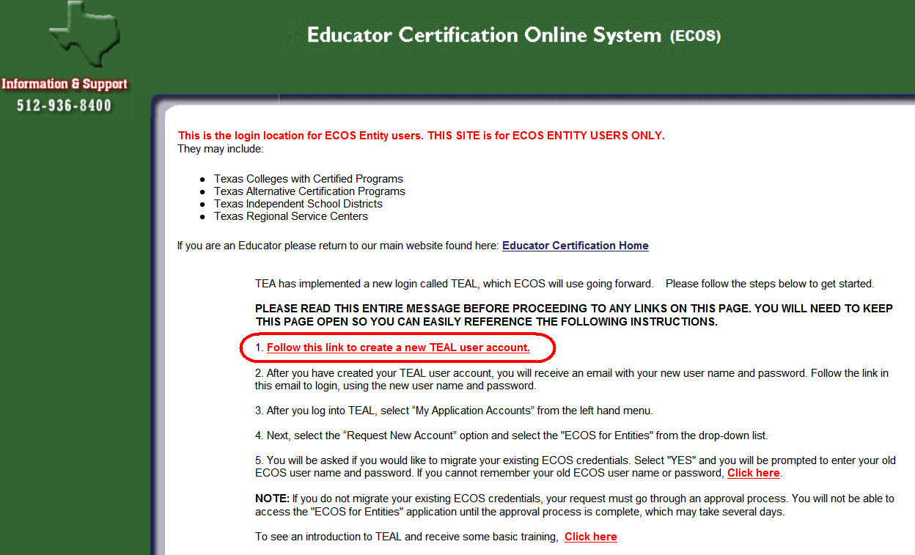

Educators will see this page:
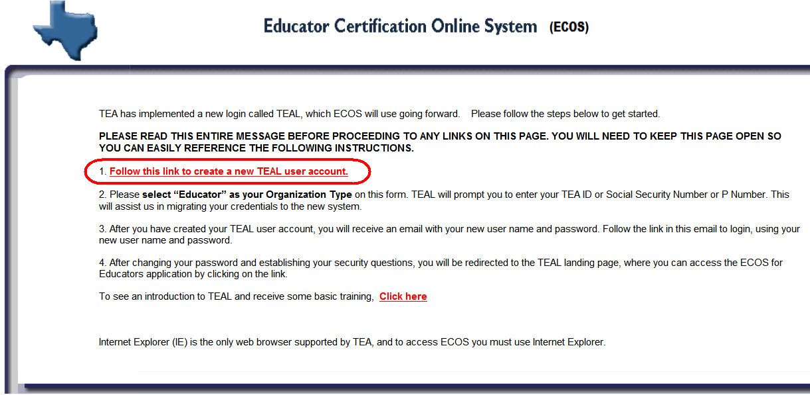

- Select the "Follow this link to create a new TEAL user account".
- The TEA New User Registration page appears. Required fields on this page are:
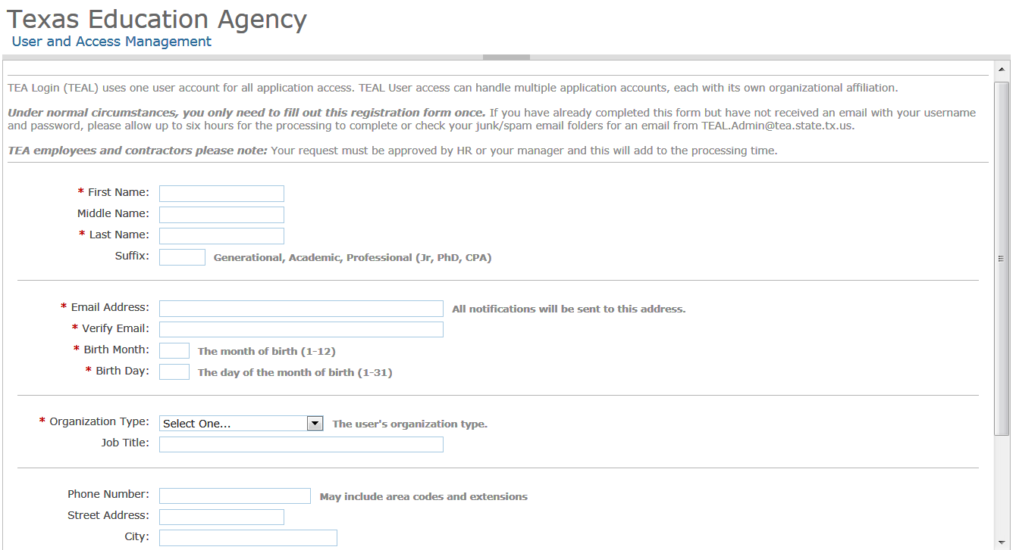

- Be sure your email information is correct. All notifications will be sent to this address, including the information necessary to log in for the first time.
- If you need access to the ECOS for Educators application, please select "Educator" as your Organization Type from the drop-down list. Educators will be prompted to enter their Social Security number, or TEA ID, or P Number so that we can transfer their credentials appropriately.
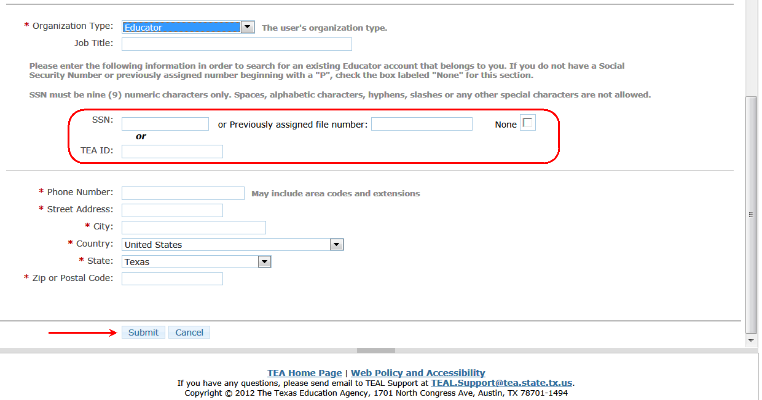
- Depending upon your organization type, you may be asked to select your manager’s name and type your job title.
- When you have completed the form, click the Submit button. A message will appear at the top of the page acknowledging your request.
- Click on the Done button at the bottom of the page to return to the TEAL login page.
- You will receive an email with your new user name, password and additional instructions.

Logging in and Out of TEAL for the first time
- There are several ways to login to TEAL for the first time.
  - Click on the login link in the email you received with your new user name and password.
  - Open a web browser and go to https://pryor.tea.state.tx.us/ .
  - Select the Educator Login button or the TEASE and TEAL Secure Applications links in the top right corner of the TEA home page: www.tea.state.tx.us
- The TEA Login page appears:
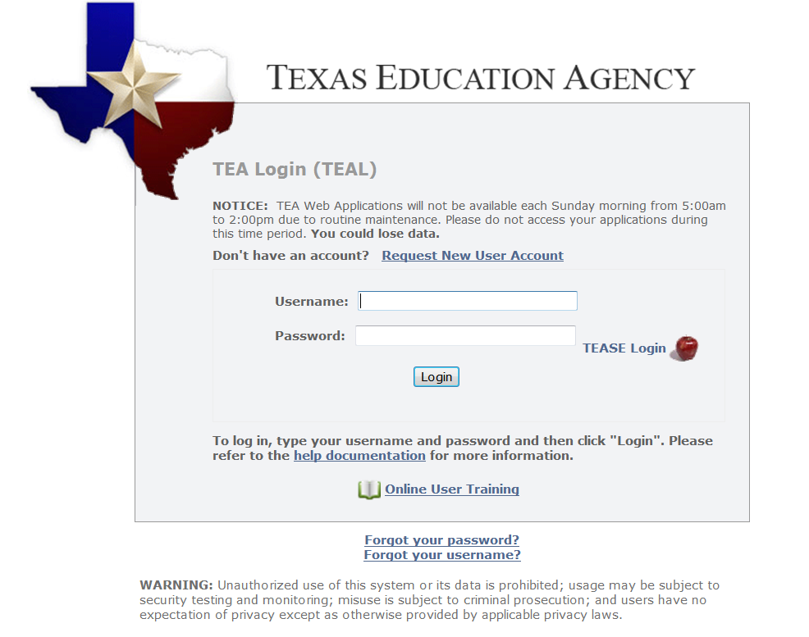
- Enter the Username and Password you received by e-mail.
- Click the Login button.
- When you log in for the first time, you will see this message: “Your password has expired. Please set a new password to continue.” You will be required to create a new password.
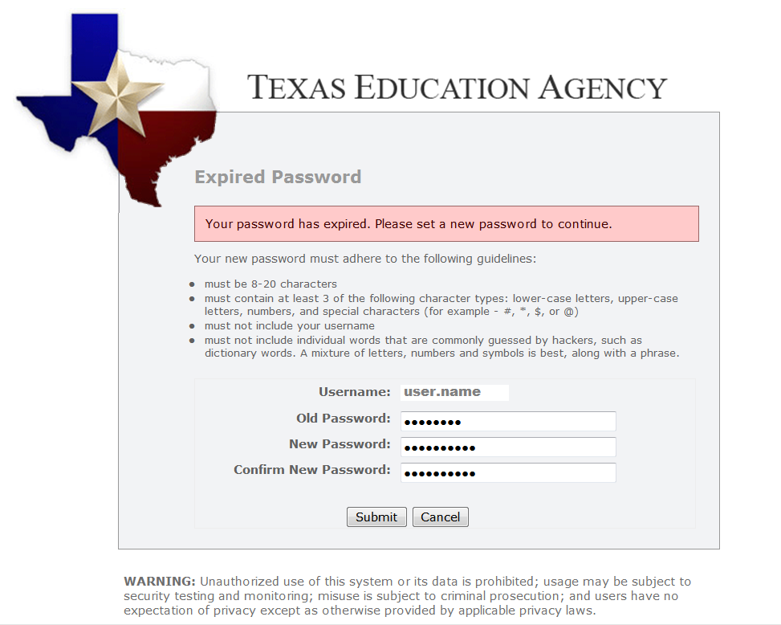
  - Click in the Old Password text box to enter the password you received by e-mail.
  - Type and retype a new password in the New Password and Confirm New Password fields.
  - Click the Submit button.

Password Guidelines
- Must be 8-30 characters
- Must contain the following character types: letters, numbers, and special characters (for example - #, *, $, or @)
- Must not include your username
- Must not contain variations of the word "password"
- Must not contain a character repeated more than 2 times
- Must not be the same as your previous ten passwords

- After your password has been reset, a Statement for Assurance of security provisions will appear. You must agree to these provisions to continue. The same provisions will appear at login every 30 days.
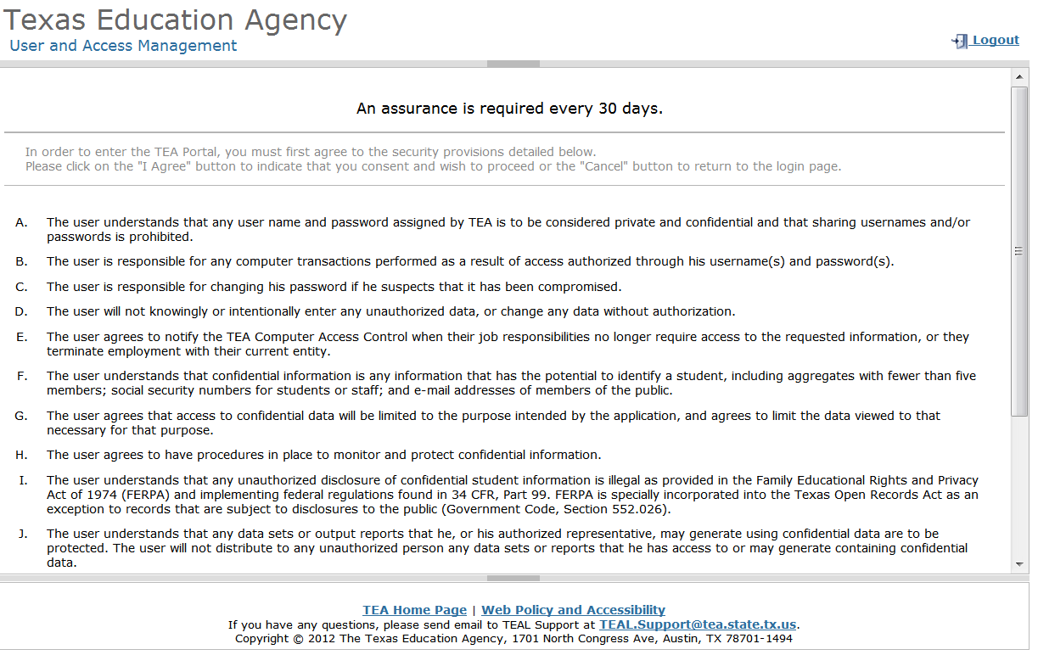

- Read the assurance provisions and click the I Agree button at the bottom of the page.
  - If you do not agree to the security provisions, click Cancel to exit the application. However, you will be unable to access applications that use the TEAL system.
- After you agree to the assurance provisions, the security questions page appears. Here, you are prompted to select and supply answers to three security questions. These questions are required and will be used to verify your identity and recover your password if you forget or lose it. These answers are confidential and will not be used for any other purpose.
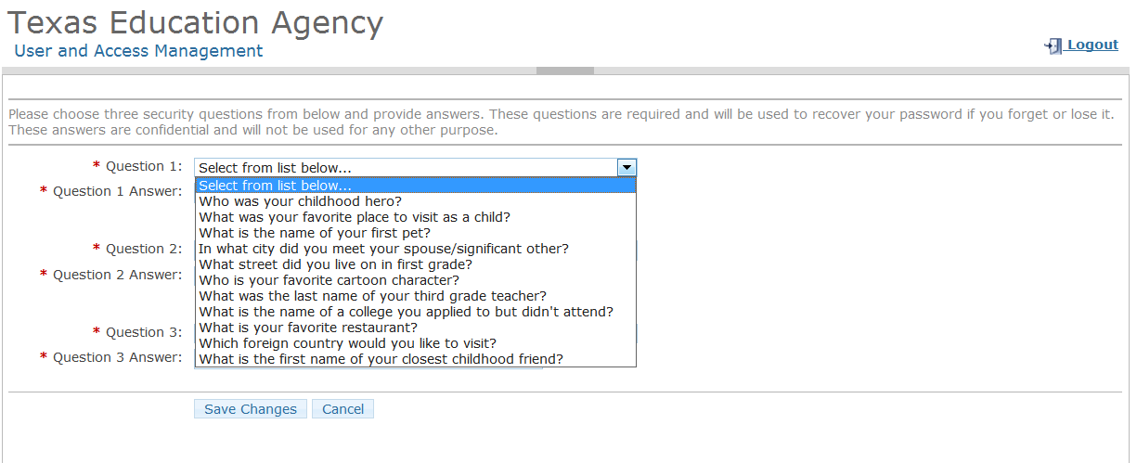
  - Be sure to note the exact answer, including capitalization, because the system needs the exact response.
For example, suppose you use the question In what city did you meet your spouse/significant other? and type the answer Ft. Davis, Texas. If, when you forget your password, you type the answer Fort Davis, Texas the system will not recognize that answer as correct.
- Click the Save Changes button
- A message appears at the top of the page that your challenge/response answers have been updated.
- The TEAL Applications page appears.

If You Already have a TEA Online Educator Account - Transfer Credentials
Educators and Entity users who previously had access to ECOS will be prompted to transfer their user credentials (roles and permissions) during the TEAL account request process.
During account request process, TEAL will ask whether you have a previous ECOS account. If you select "Yes" TEAL will prompt you to provide your previous ECOS user name and password. The following screen shots show how an Educator will transfer their credentials. Entity user transfer follows the same process.

- Login to the TEAL application by selecting the Educator Login button or the TEASE and TEAL Secure Applications links in the top right corner of the TEA home page, www.tea.state.tx.us. Also, you can open a web browser and go to https://pryor.tea.state.tx.us/.
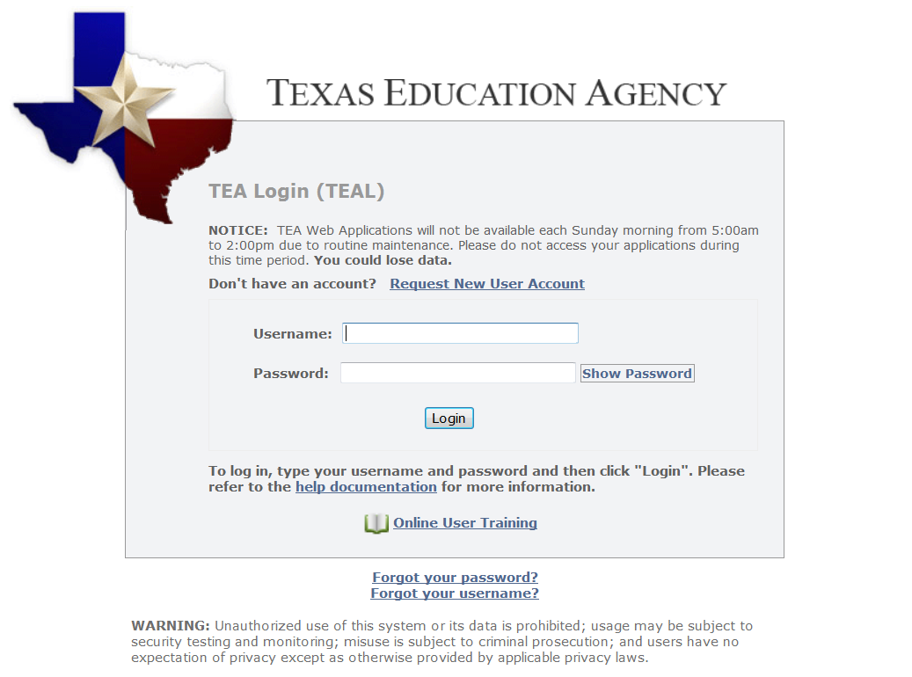

- Next, click My Application Accounts button on left hand menu (A).
- Click Request New Account button in “My Accounts” page (B).
- Select ECOS for Educators row in the list of available applications (C).
- Click Go To Account Details Form button at bottom of page (D).
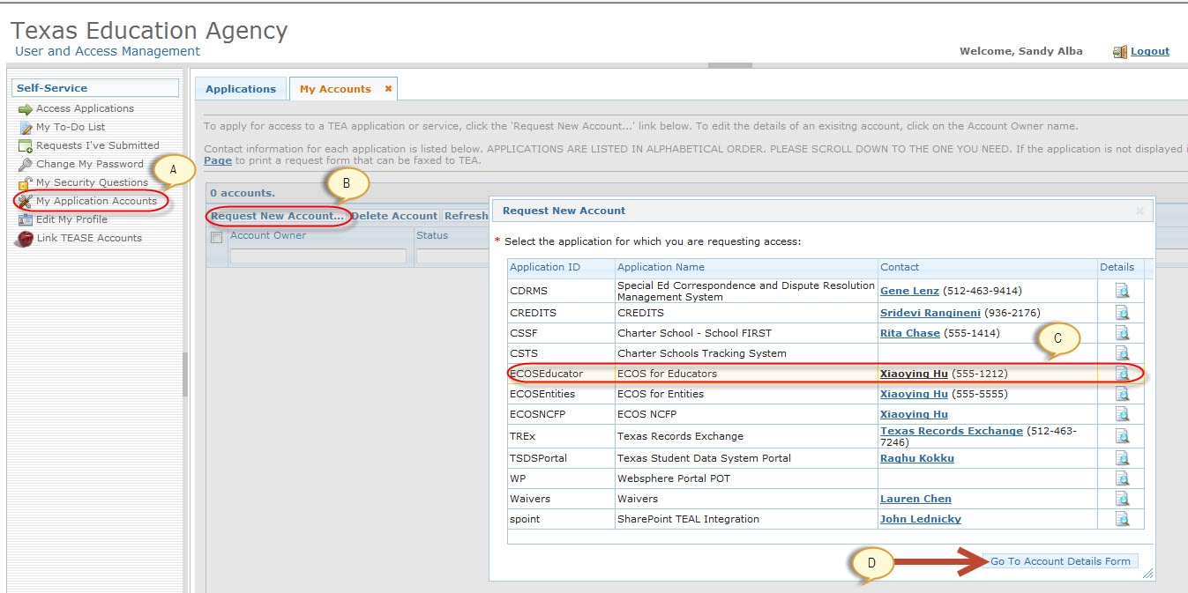

- You will be asked whether you have an existing TEA Educator Certification Online System (ECOS) account and password.
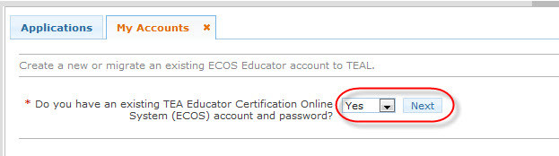
- Select Yes from drop down box.
- Click Next button to proceed converting existing ECOS account to TEAL account.
- You will be asked to enter your existing ECOS User ID (this is your ECOS user name) and ECOS Password. If you do not remember your ECOS account information, click “Here” link to retrieve your ECOS user name or password.
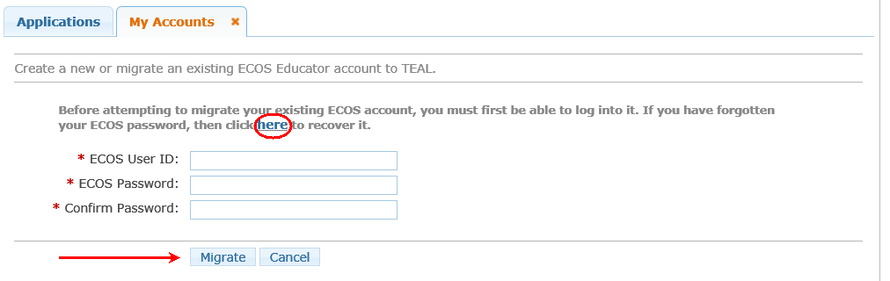

- Click “Migrate” to transfer existing ECOS user credentials to your corresponding TEAL account.
- A message will be displayed indicating your credentials were successfully transferred and TEAL will create a new Educator account. A red error message means the transfer failed. Please follow the message instructions to find out what to do next.

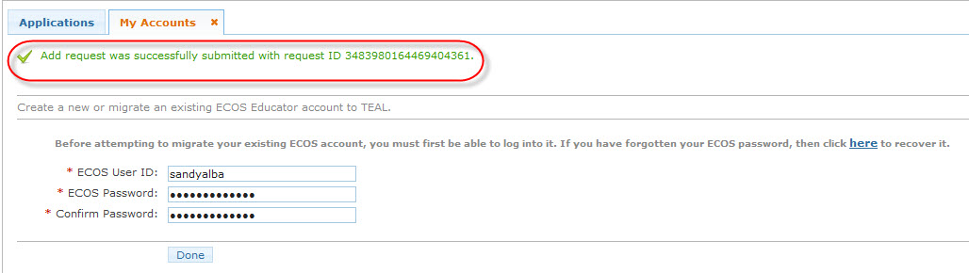

Requesting New Access to an ECOS for Entities or ECOS for Admin Application
NOTE: This section is not applicable to Educators who selected "Educator" as their Organization Type during TEAL Self Registration. These users will automatically be given access to the ECOS for Educators application during the self-registration process.
A TEAL username and password alone does not automatically grant access to TEA applications. You will need to submit a request and receive approval in TEAL to access each application.
- When you log in for the first time, you will not have access to any TEA applications, unless you are an educator (educators will automatically be given access to the ECOS for Educators application when requesting a new TEAL user account). All other users must select Apply for Access link on their TEAL landing page OR click the My Application Accounts link in the Self Service section in the upper left column of the page.
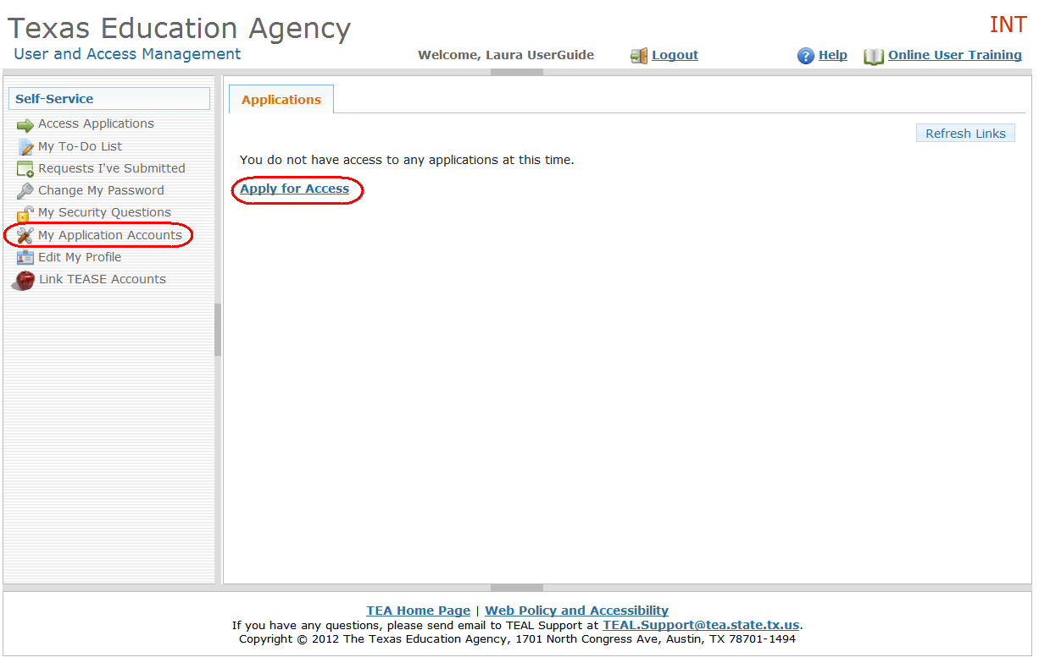

- The My Accounts page appears where you can apply for access to a TEA application or view the applications to which you already have access. Click the Request New Account button on the My Accounts page.
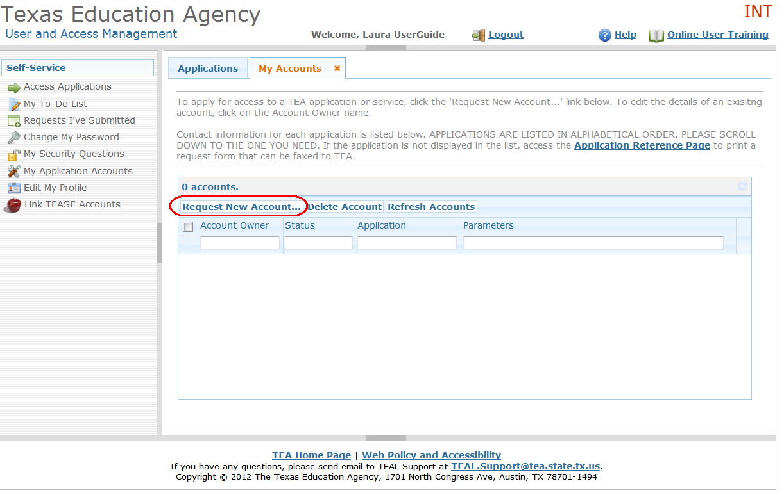

- A list of TEA applications will appear (see below). There are three ECOS applications, one for Educators ("blue screens"), another for Entities ("green screens") and finally, one for TEA Administrators. Highlight the ECOS you are interested in and double click.
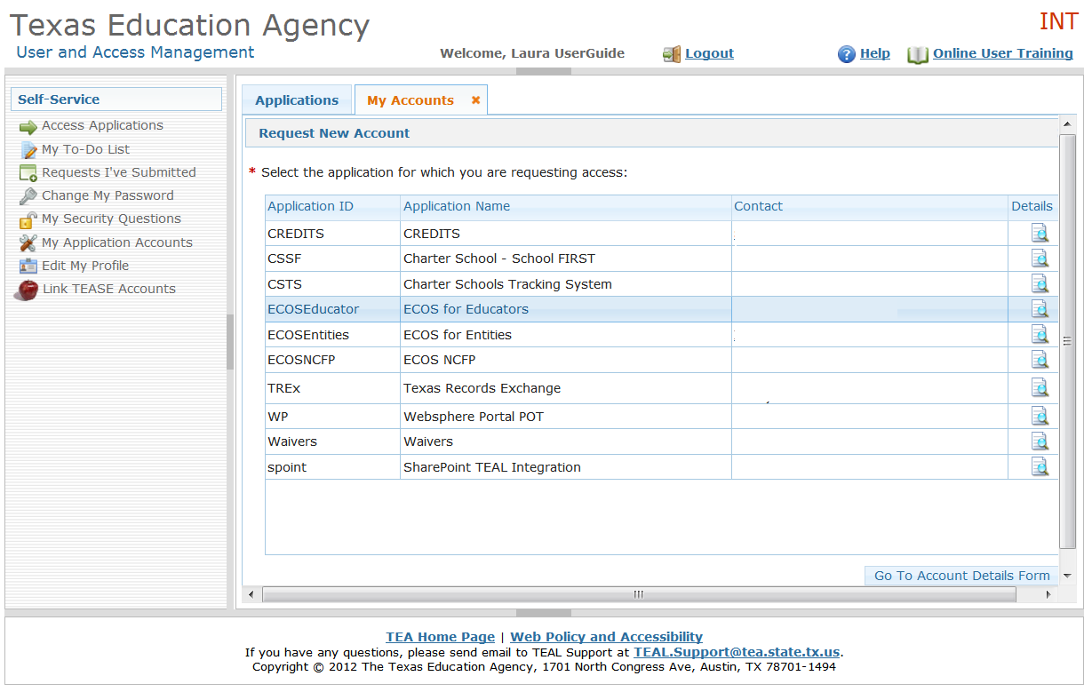

- The Application Access page appears. Click the Add Access button.
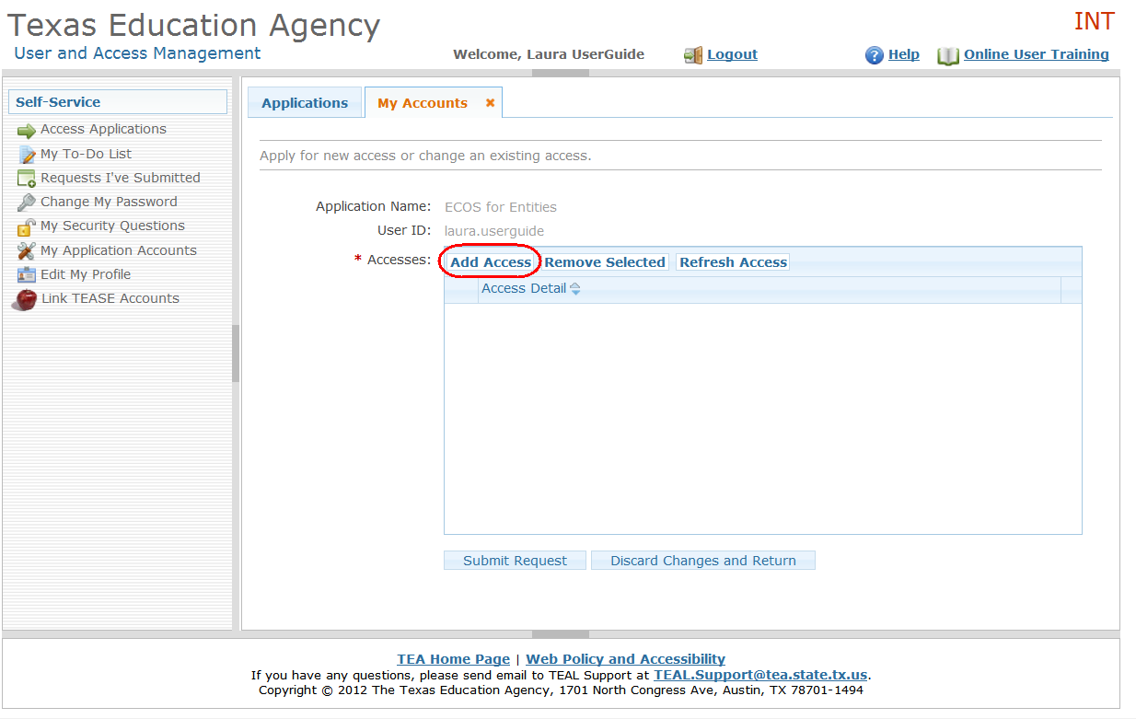

- You will be asked whether you have an existing TEA Educator Certification Online System (ECOS) account and password. See the next section in this document regarding how to transfer your existing ECOS credentials to TEAL. For this example, select "No".
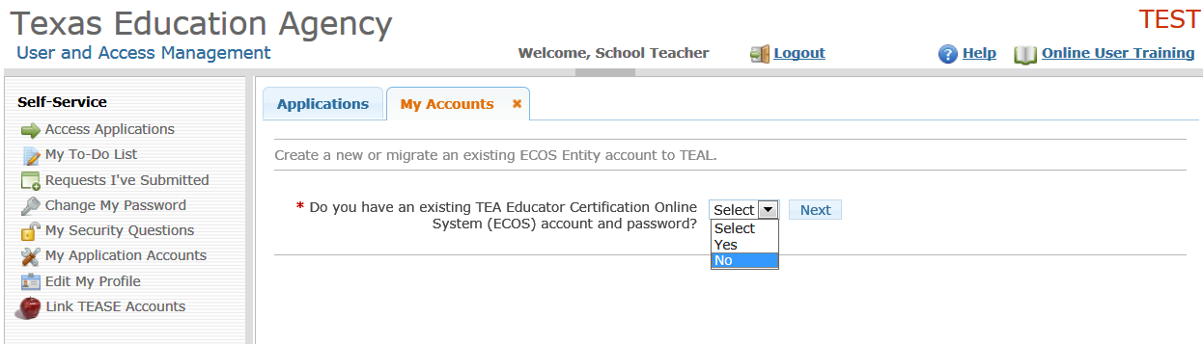

- The Application Access Details page for the selected application appears. This page will be different for each application and this is an example for the ECOS for Entities ("green screens") application.
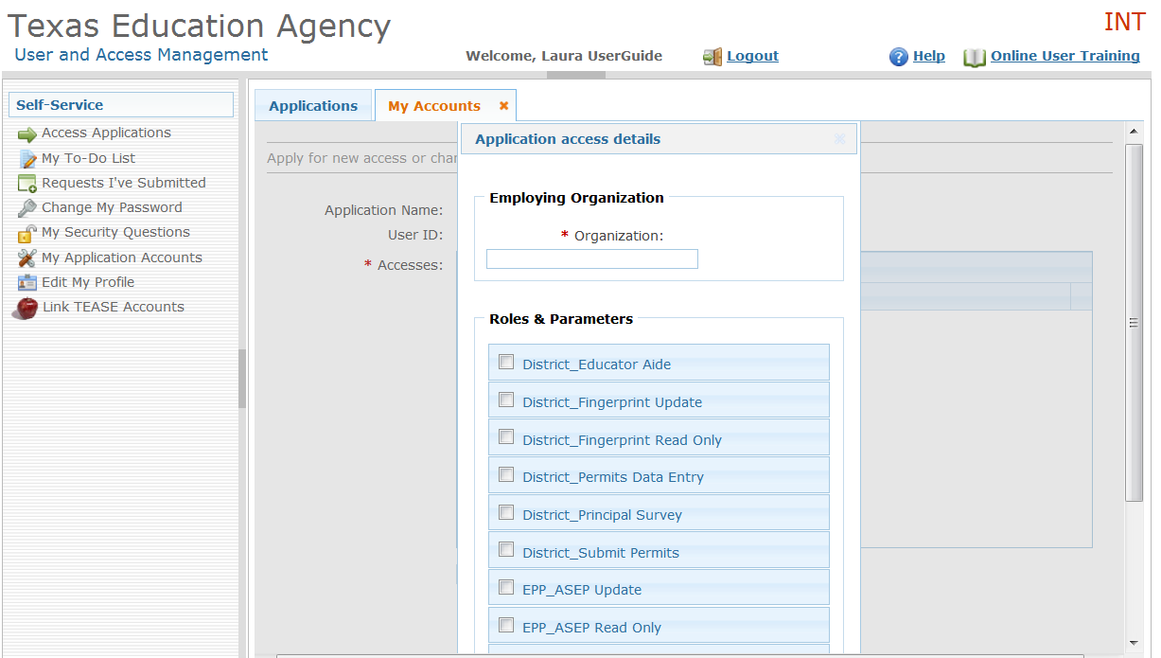

- Click in the Employing Organization field at the top and enter your employing organization name or ID. TEAL will display a list of possible choices, based on what you have typed.
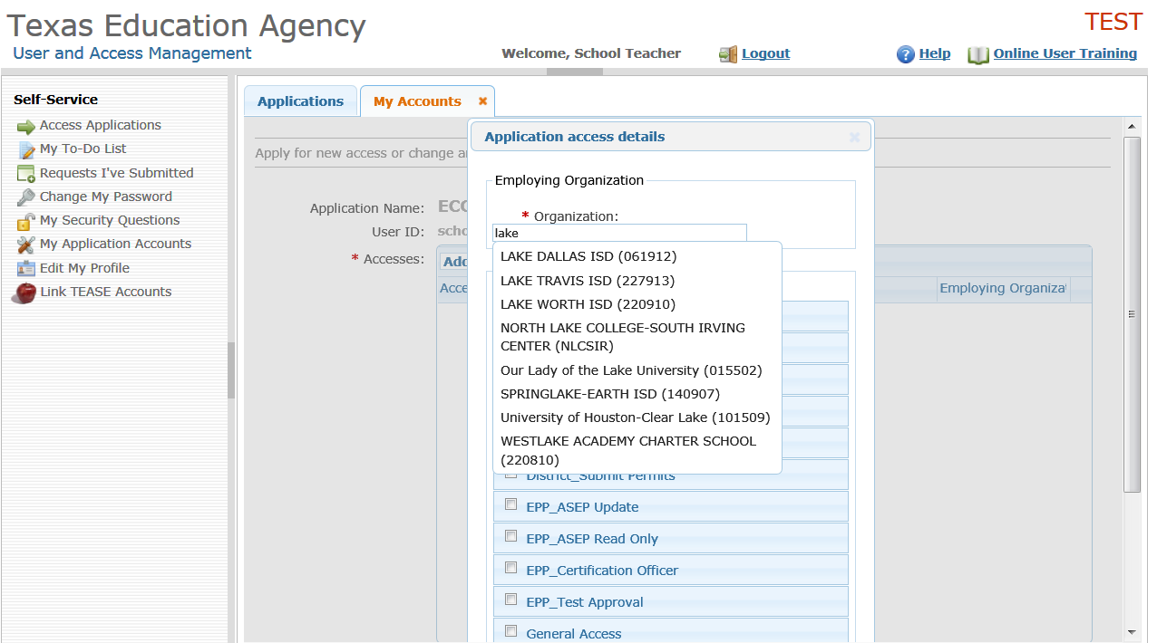

- Next, select a checkbox for your role. TEAL will display a description of the role you have selected.
  - NOTE: If you are requesting access to the ECOS for Entities application, when you select a role(s), you will also have to provide the Organization name or ID for the entity whose data you are requesting access. Usually, this is the same as your employing organization, but occasionally, some Entity users need to access more than one entity's data.
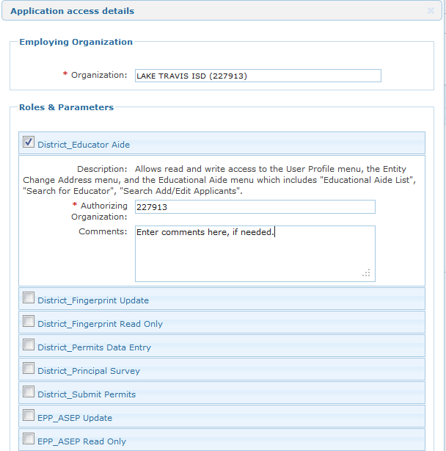

- Type in any additional details related to the request in the comments section, if required.
- Click the Done button at the bottom of the page.

- The application request now appears on the Application Request page.
- Click the Submit Request button at the bottom of the page.
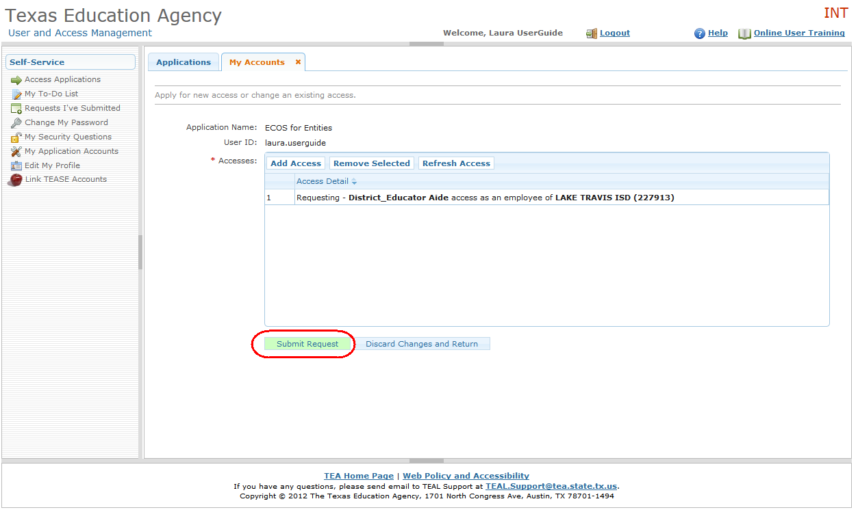

- A success message appears that the request was submitted successfully. Note: You can submit multiple requests at the same time, as long as access to a different application or organization is requested each time.
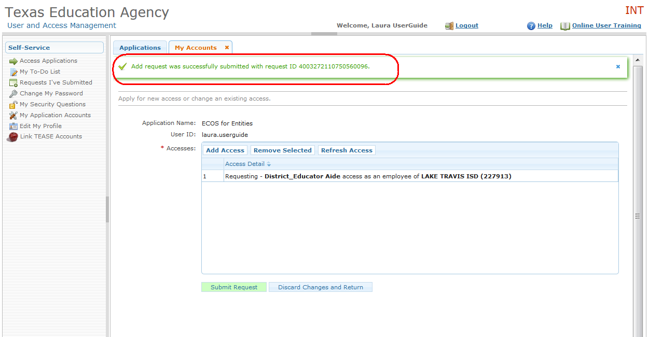

Request Approval Process
Now that you've successfully submitted your request for access to an ECOS application, the request must go through an online approval process. Access requests to all applications in TEAL must be reviewed by at least two approvers.
The Organization Approver provides the first level of approval. It is their responsibility to verify that the Requestor is part of their organization, and that the Requestor should have access to ECOS in the role that is being requested. The primary organization approver is the leader of that organization, such as the school district superintendent or the EPP Director.
Service Approvers provide the final approval for access requests to ECOS applications. Service approvers are TEA employees with deep understanding of the application and the relevant roles and permissions.
A denial from any approver will result in an email notification to the requestor.
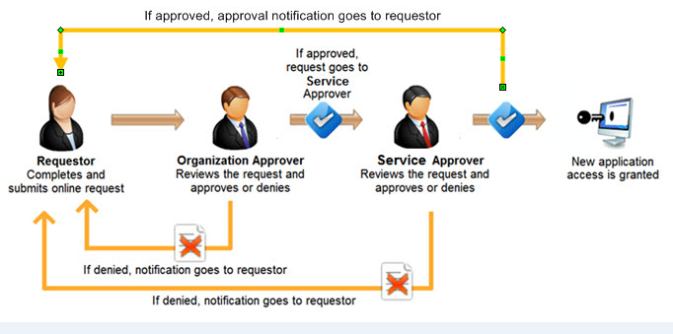

Accessing an ECOS Application
After you have requested and been granted access to an ECOS application, you can easily access that application through TEAL by clicking the Access Applications link in the Self-Service section. ECOS for Educators, ECOS for Entities and ECOS for Admins will each have separate links.
If you have access to multiple applications, each application will be listed separately, as seen below. If you have been granted access for more than one organization, each organization and the roles you have been approved for will be displayed and accessed through separate links.
When you select the access link, the application opens up in a new web page.
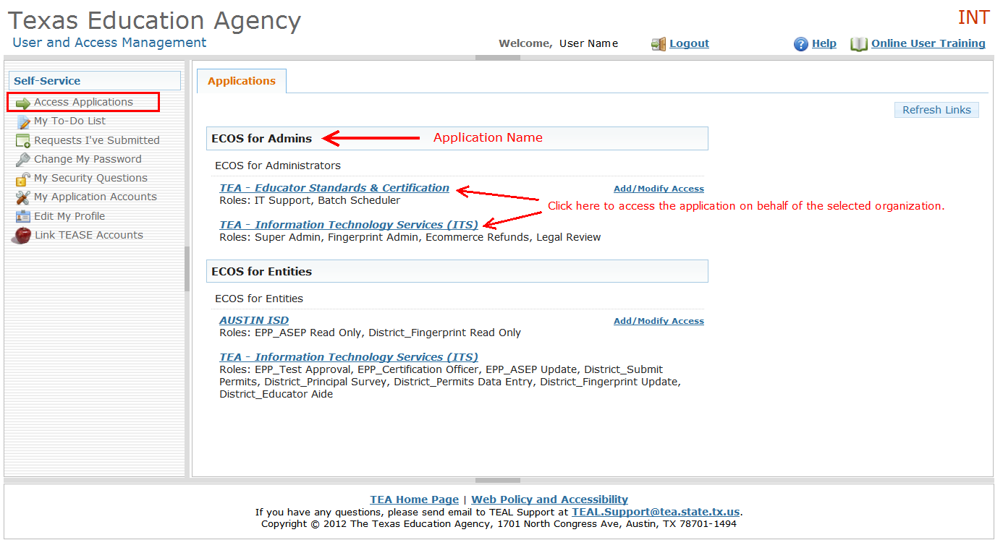

Getting a Password Reset and Username Reminder
- Select the Educator Login button or the TEASE and TEAL Secure Applications links in the top right corner of the TEA home page: www.tea.state.tx.us. Also, you can open a web browser and go to https://pryor.tea.state.tx.us/.
- The TEA Login page appears:

Forgotten Password
- Click the Forgot your password? link.
- The TEAL password reset page appears, where you need to enter your Username.
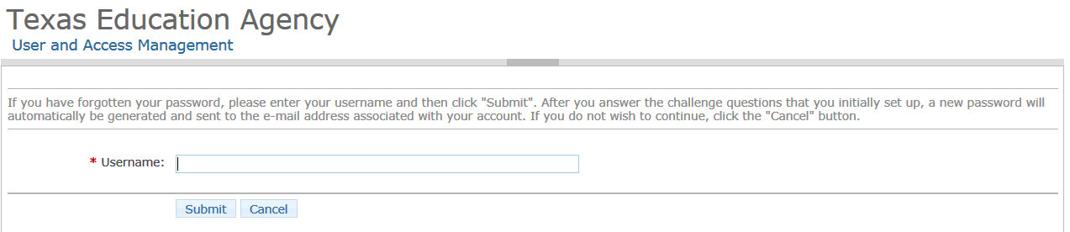
- Click the Submit button.
- You will be asked to answer the three security questions you selected when registering.
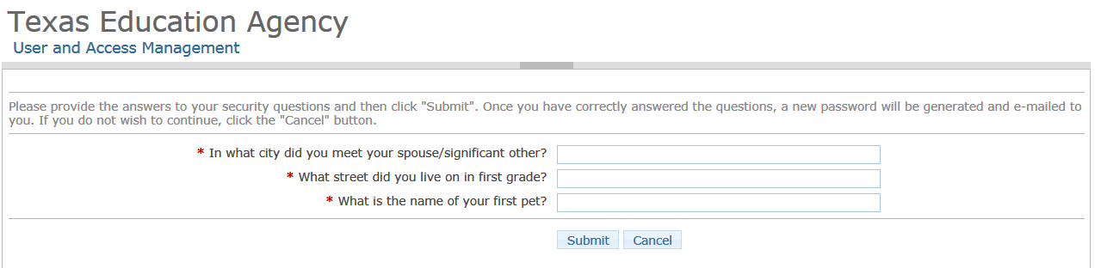
- Click the Submit button. If you answered the questions correctly, an automatic e-mail is generated containing a new password, which you must change as soon as you log in again.

Forgotten Username
- Click the Forgot your username? link.
- The Forgot User Name page appears. Type your e-mail address. This address must be same as the one associated with your username; otherwise, the system will not be able to identify you.
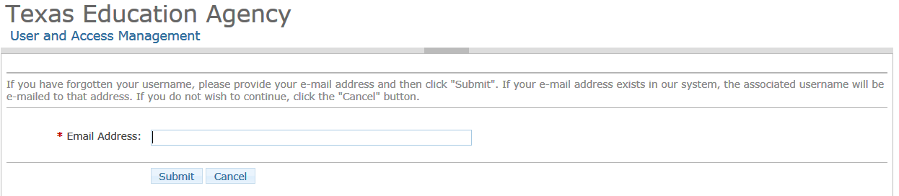
- Click the Submit button.
- An email with your TEAL user name will be sent to the email address on your TEAL user record.
- A message appears that your username has been sent to your e-mail address.
If you do not receive an e-mail shortly, contact TEAL.Support@tea.state.tx.us at the e-mail address shown on the page.

User Profile Updates
After TEAL integration, some ECOS identity information will be managed in TEAL instead of within the ECOS application. This applies to all ECOS users including educators, entity users and TEA staff. Identity data impacted includes:
- First Name
- Last Name
- Month of Birth
- Day of Birth
- Email address
Below is an illustration of how educator’s profile setup looks like after TEAL integration.
When an educator accesses the ECOS for Educators application for the first time, the educator will be required to review and complete their profile information before they can navigate to any other page. This includes entering their birth year, phone number, ethnicity, driver license number and state.
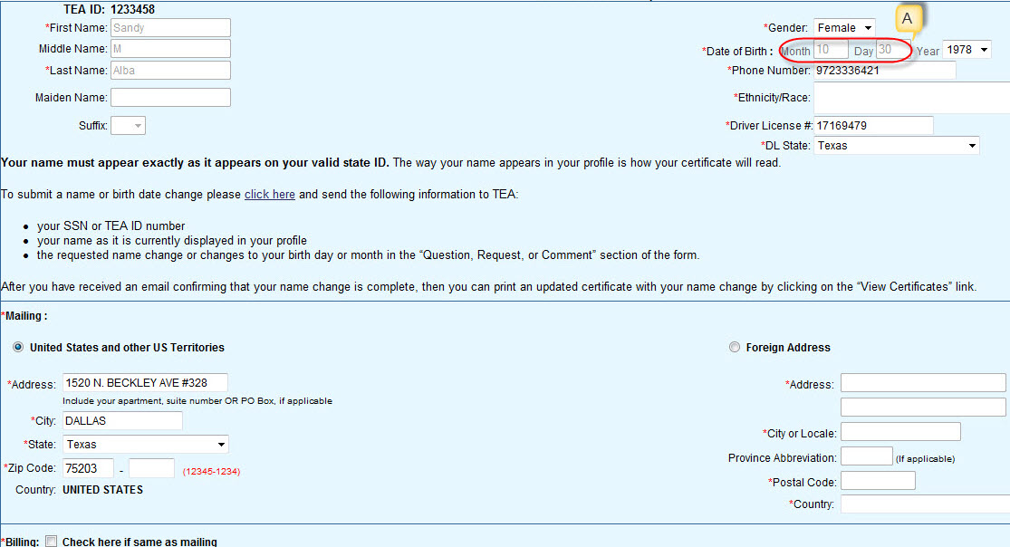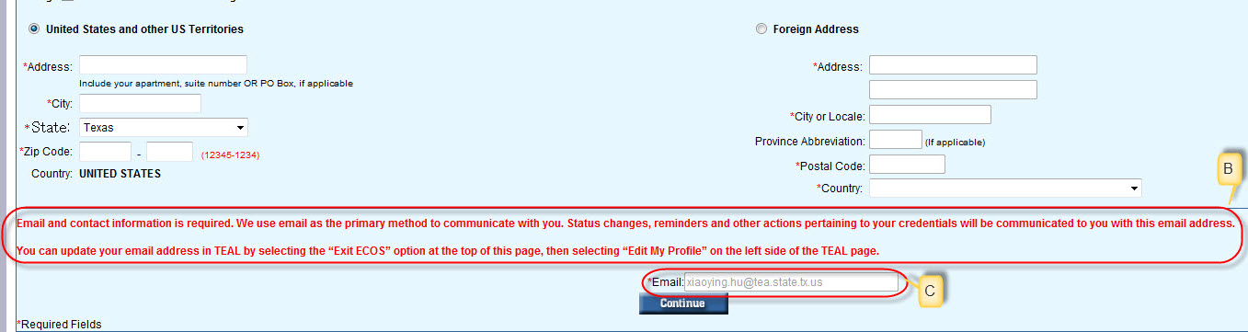
The following are changes to educator profile page:
- Educators will no longer be able to change their month and day of birth (see “A”). To request birth day and/or month change, they must follow the same process used for name changes by sending an email request to TEA. There is a link on this page to send the email request.
- Email address must be changed in TEAL application(see instruction on how to change email address in “B”). Once email address is changed in TEAL, the educator will be able to see the updated email address (see field noted as “C” in the screen shot) next time they login to ECOS for Educators.
- Each time a user’s profile information (first name, last name, month of birthday, day of birthday, email address) is changed in the TEAL application, a notification email will be sent to the user.

Other Self-Service Features and Help
You can use the Self-Service features to edit your TEAL profile, check the status of requests you have submitted, and change your TEAL password.

