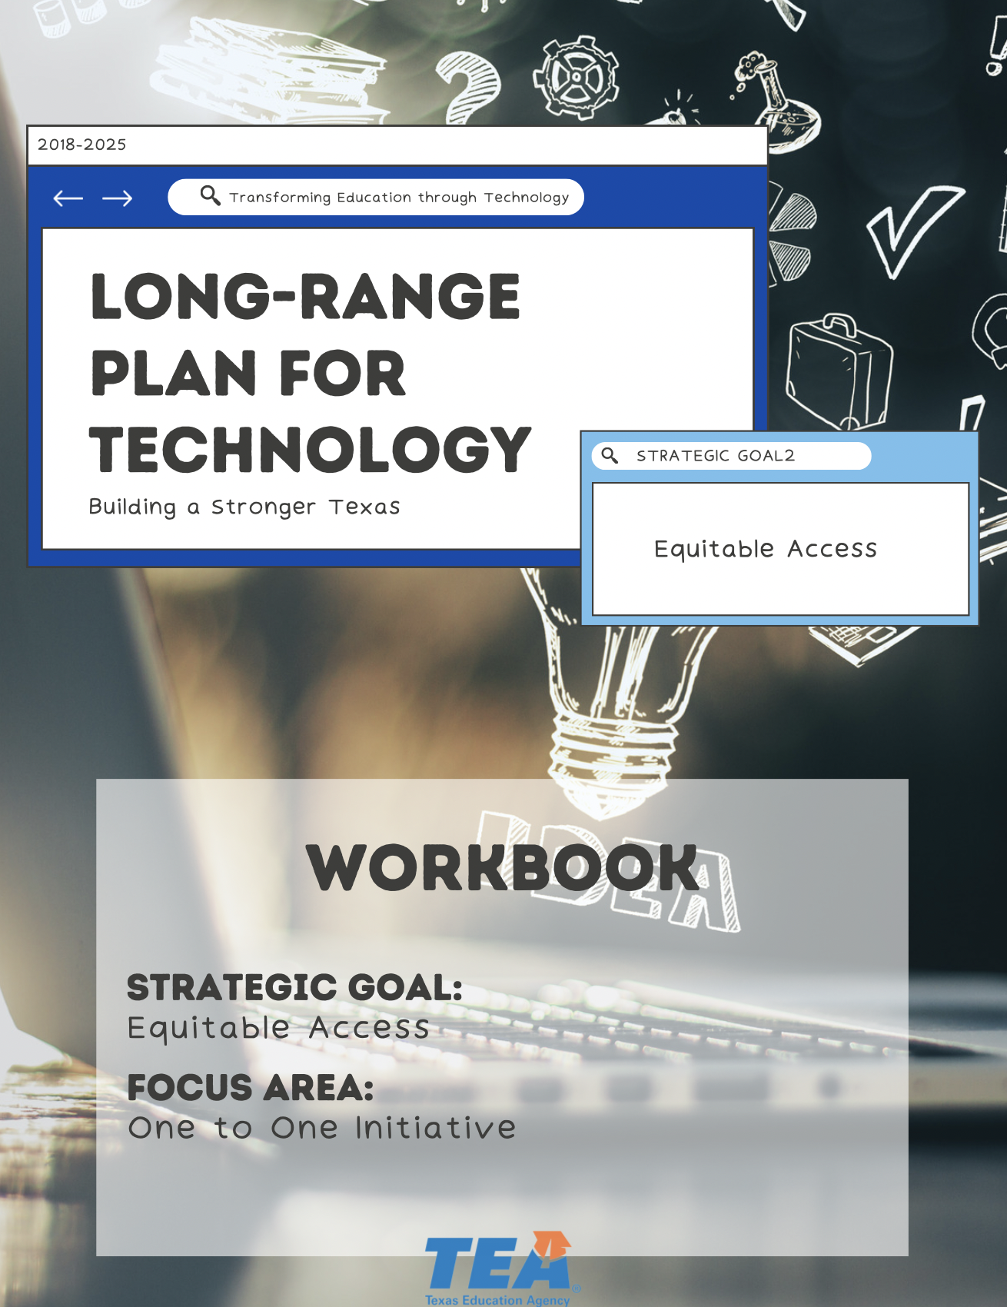

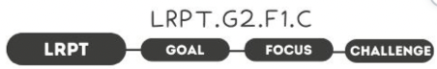

1. Take Note & Reflect:
How is your district addressing funding and implementation? What is keeping districts from full and dynamic 1:1?

2. Take Note & Reflect:
What is your district's current implementation strategy? As you have been implementing and adjusting, what have been the results? Write important notes here about your implementation strategy and results achieved.

3. Take Note & Reflect:
What would the outcome be if you overcame all your hurdles?

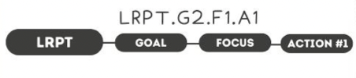

1. Take Note & Reflect:
What funding sources have you used for 1:1? How will you identify future funding sources for 1:1? Is there a portion of your traditional budget allocated for 1:1?

2. Take Note & Reflect:
Reflect on your districts use of future funding. How will you stay current on future funding as it's made available through various avenues? Does your district have a portion of it's traditional budget allocated to the 1:1 initiative? How will that amount be allowed to evolve as needed?

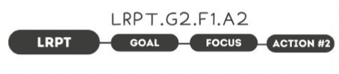

1. Take Note & Reflect:
Reflect on standards that are already in place in your district for device care, learning, and access. What is poor device care?

2. Take Note & Reflect:
Reflect on the accountability practices you have in place for devices. Does your district have clear standards and accountability practices in place?

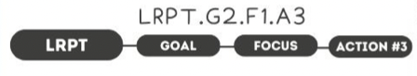

1. Take Note & Reflect:
What is a strategic implementation plan? What are your current structures, policies, and technology for innovation in your district?

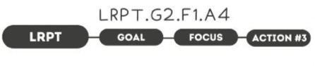

1. Take Note & Reflect:
How are stakeholders being included in 1:1 currently and what involvement opportunities exist for stakeholders in the future?

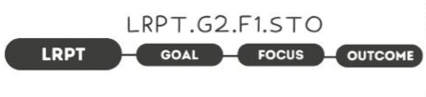

1. Take Note & Reflect:
Reflect on personalized content for your district. What does personalized content that uses technology to foster creative and innovative work look like?

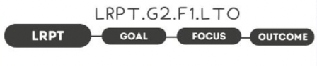

1. Take Note & Reflect:
Define a fully prepared/independent thinking, tech savvy student population. What does that look like at your district?

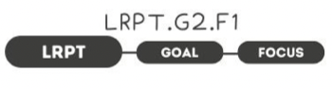

1. Take Note & Reflect:
Write a short summary statement for this focus area. How would you summarize what you've done and what you need to do for this focus area based on your work so far?

