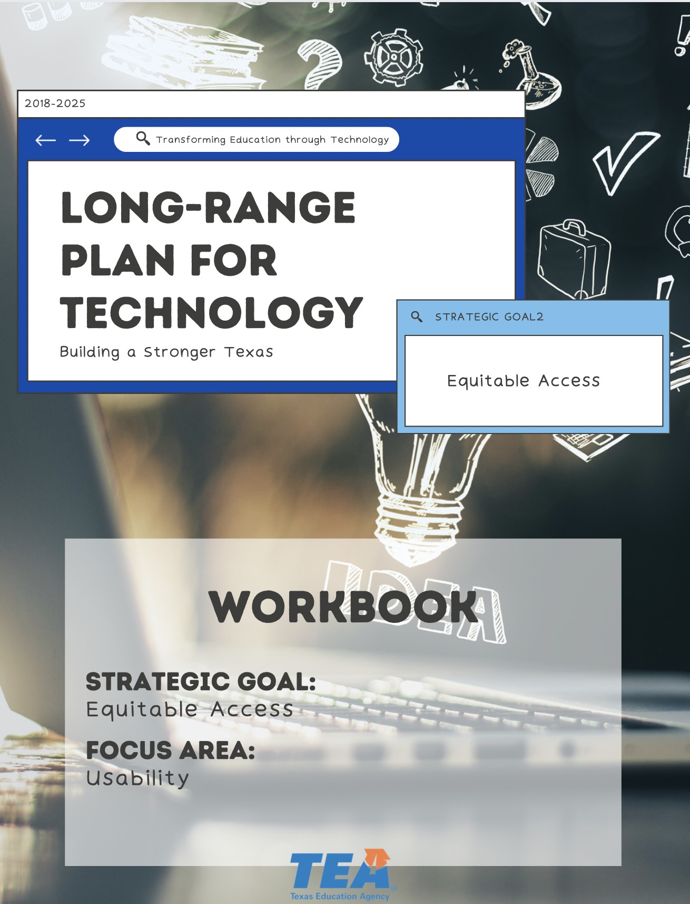

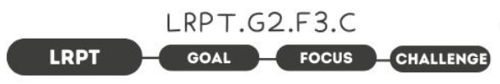

1. Take Note & Reflect:
How are you providing digital skills as a part of your overall technology plan and remaining aware of the skills gap?

2. Take Note & Reflect:
What does a successful learning environment include for your district?

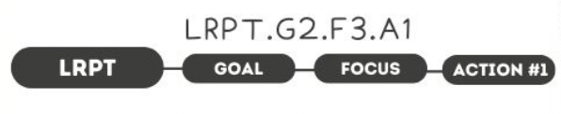

1. Take Note & Reflect:
Use this space to write down your core platforms, tools, and their users in your district.

2. Take Note & Reflect:
Reflect on the training your district provides. How are trainings designed for your core platforms, tools, and their users?

3. Take Note & Reflect:
Reflect on the digital platforms in your district. What instruction/training does your district provide? Who designs the trainings and when is it given?

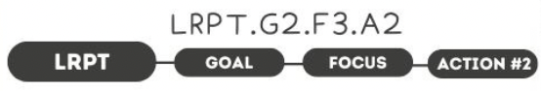

1. Take Note & Reflect:
Take a moment to reflect on your current help processes. What support do you provide for your school community?

2. Take Note & Reflect:
How are you ensuring the relevancy of the support you provide your school community?

2. Take Note & Reflect:
Take a moment and reflect on your districts most common needs and how your support system stays current. How are you tracking the needs of your community?

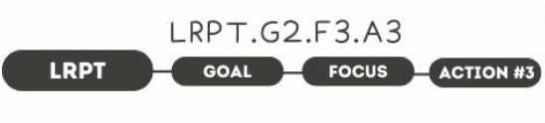

1. Take Note & Reflect:
How would identify a diverse learner who needs technology support in your district? How would that vary from traditional special instructional needs?

2. Take Note & Reflect:
How are you already using assistive technology in your district? How could you increase this support?

3. Take Note & Reflect:
How are you providing support and training for assistive technology? How will you continue to accommodate learners?

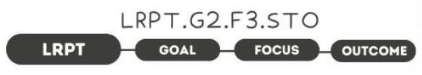

1. Take Note & Reflect:
Use this space to reflect on your current user experience. How will you use the tools and ideas discussed to continuously improve the user's experience?

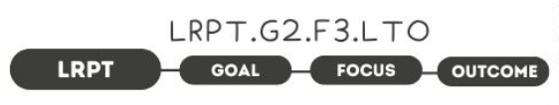

1. Take Note & Reflect:
When the technical frustrations are removed, what does the classroom look like? What are the benefits the students and staff will experience? Brainstorm what this would look like for your district.

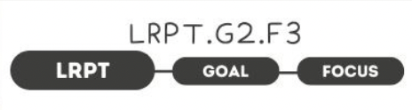

1. Take Note & Reflect:
Write a short summary statement for this focus area. How would you summarize what you've done and what you need to do for this focus area based on your work so far?

