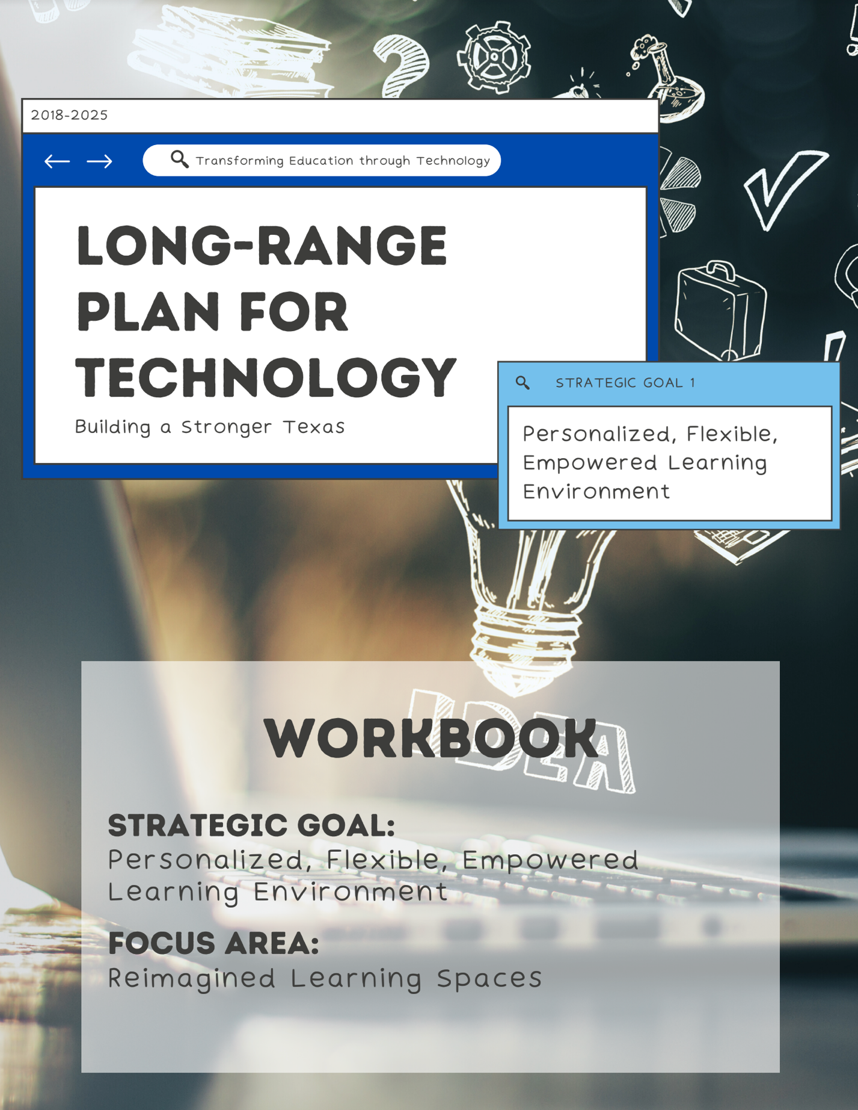

1. Take Note & Reflect:
Reflect on your resources. Would you say that you have a strong awareness of resources that are available for tech challenges? Does your district have a clear understanding of the vision and goals of the oversight agencies?

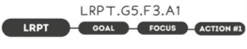

1. Take Note & Reflect:
What does your district's relationship with state leadership look like? Reflect on areas for improvement and possible action steps in your district.

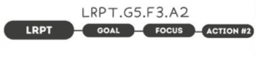

1. Take Note & Reflect:
How participatory is your district in advisory committees for technology, security, and the like? Is there a group you participate in regularly that allows input and concerns around technology?

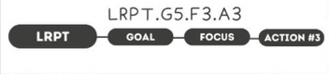

1. Take Note & Reflect:
How is your district learning from the success of others? How are you staying aware of resources available from the state and federal government?

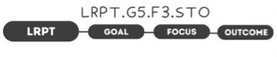

1. Take Note & Reflect:
What would it look like for your district to work more effectively with others towards a common goal?

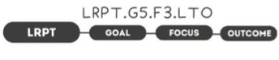

1. Take Note & Reflect:
What would 'better results', 'greater innovation'. and 'higher productivity' look like for your district?

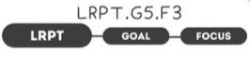

1. Take Note & Reflect:
Write a short summary statement for this focus area. How would you summarize what you've done and what you need to do for this focus area based on your work so far?

