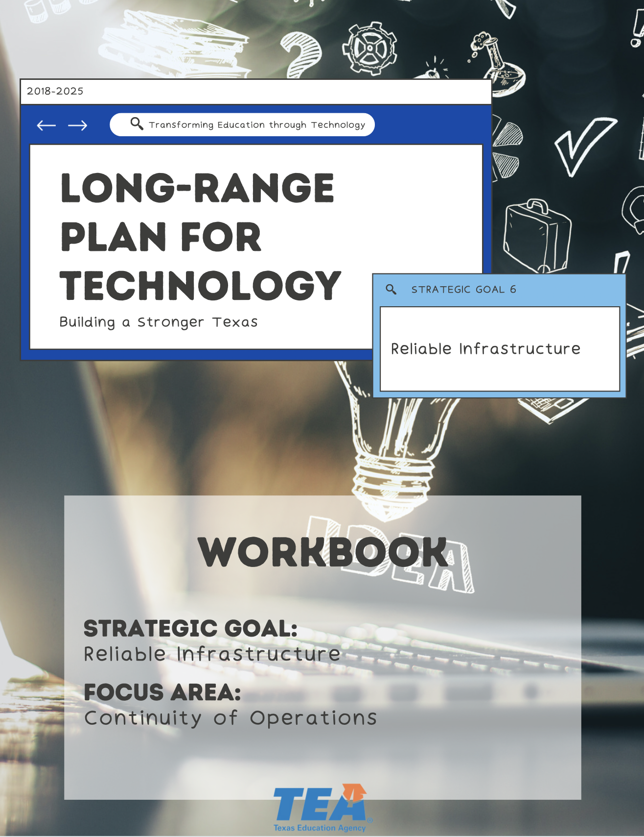

1. Take Note & Reflect:
Reflect on your districts business continuity plan. What does this look like for your district?

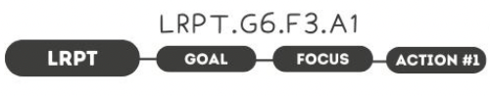

1. Take Note & Reflect:
How is your district's business continuity plan routinely reviewed?

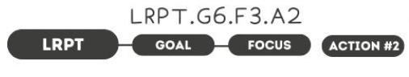

1. Take Note & Reflect:
Does your districts plan include cloud infrastructure? What are examples of cloud services that you currently use?

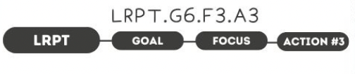

1. Take Note & Reflect:
Reflect on your districts current worksite policies. Use this space to write down how you currently manage your alternate worksite policies and how you plan to continue to build on this piece of your continuity plan.

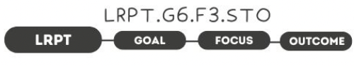

1. Take Note & Reflect:
Who would you currently list as your critical personnel, facilities, and resources?

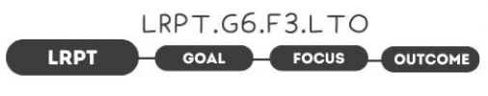

1. Take Note & Reflect:
What would a holistic approach to incident management allow for your district?

Take Note & Reflect:
Write a short summary statement for this focus area. How would you summarize what you've done and what you need to do for this focus area based on your work so far?

