The campaign resources outlined below are intended for school systems to adopt or adapt to share with their communities regarding the COVID-19 vaccine. In particular, for the school systems who are working to provide vaccine clinics for students and/or LEA community members, these messages could be used to link to information about the vaccine clinic being provided (e.g. sign up link, etc…). If a clinic is not being provided, the school system could link to either the Department of State Health Services COVID-19 Vaccination page, local city/county resources on vaccination, or CDC resources on vaccination.

The intent of this campaign is to share factual information with families who are deciding whether they or their children should get a vaccine. Vaccination is always an option available to a student’s parent, not a mandate, and none of these messages are intended to suggest otherwise.

School systems can choose to use some of these resources or all of them, and to adapt them as needed to meet their community’s needs.

TEXT MESSAGES

Message 1:
Children 5-11 are now eligible to receive the Pfizer COVID-19 vaccine. These safe, effective vaccines reduce the risk of severe illness and/or hospitalization. Learn more: [INSERT LINK HERE]
Message 2:
The COVID-19 vaccine helps keep students healthy and allows them to safely get back to doing what they love. Consider getting the safe, effective COVID-19 vaccine – the best tool to prevent severe illness and hospitalization. Learn more: [INSERT LINK HERE]
Message 3:
COVID-19 vaccines are highly effective at preventing severe disease and death. Consider a vaccination for you and your family to #StopTheSpread. Learn more: [INSERT LINK HERE]

SOCIAL MEDIA POSTS

Graphic 1:
These graphics are also available as separate high-quality files on TEA’s Public Health Website under Vaccine Resources.

Graphic 2:

Graphic 3:
Sample Post 1--goes with graphic 1 (kids playing soccer)
Students and Families: As we head #BackToSchool, now is the time to have your children ages 5-11 vaccinated against COVID-19. Help them get back to doing what they love, safely. Find a provider near you for your free #COVID19 vaccine: (URL) #DontMissYourShot

Sample Post 2--goes with graphic 2 (hallway)
Students and Families: The #COVID19 vaccine is safe, effective, and your best defense against the virus. Safely get your children back into the classroom and find a vaccine provider near you (URL). #BackToSchool #DontMissYourShot

Sample Post 3--goes with graphic 3 (bus):
As of November 2nd, children ages 5-11 years old across Texas are getting vaccinated! Be a part of that growing number and get your children ages 5-11 vaccinated against #COVID19. Find a vaccine provider near you: (URL). #BackToSchool #DontMissYourShot

Sample Post --- goes with graphic 4 (classroom):
The #COVID19 vaccine is safe, effective, and your family’s best defense against the virus. Check out these FAQs provided by @TexasDSHS to learn more: bit.ly/3iHFcwF.

For post 5, school systems could use their own visuals, or could use visuals created by DSHS, including:
- Videos speaking to parents about the COVID-19 vaccine
- DSHS COVID-19 Vaccination Toolkit

Sample Post 5:
As we head into the holidays, now is the time to have your children ages 5-11 get vaccinated against COVID-19. Protect your children from COVID-19, so that they can focus on having fun. Find a vaccine provider near you today: covidvaccine.texas.gov.

HTML EMAIL TEMPLATES AND MESSAGING
These emails are available in HTML code, which can be found as separate documents at Vaccine Resources on TEA’s COVID-19 Public Health Orders page.
Email Blast 1 (More Storytelling):
Text:
Email Blast 1 (More Storytelling):
Blue Header:
Vaccine Clinic Now Available in [District] for 5-11 year olds!
Salutation:
Dear _District Name_ Parents
Body text:
The recent approval of the pediatric vaccine for children ages 5 – 11 years old expands the opportunity to get vaccinated for an additional 28 million children in the United States. Nearly 1 million children have already been vaccinated in the first week of eligibility.
Here at __district name_, we are wishing our students and families a safe, happy holiday season, and the safest way for families to spend this time of the year together is for all eligible family members to be vaccinated against COVID-19.
We are partnering with vaccine providers like pharmacies and local health departments to administer free and safe COVID-19 vaccines to any eligible student, with parental consent. [Insert details on vaccine clinic here]

Families and students alike have been through so much over the past year. Feel safer this winter season, and don’t miss your shot to ensure your child can get back to spending time with the friends and family they love.

Sincerely,
_District Superintendent_
Button text: Get Your Shot
Link: [INSERT LINK HERE]
Preview image of HTML email using this text (for illustrative purposes only)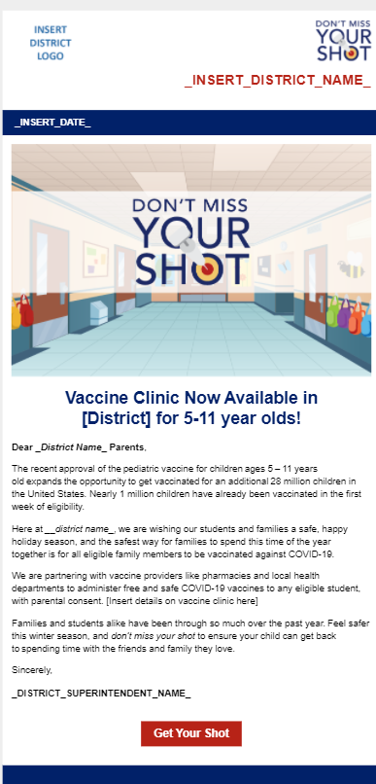

Email Blast 2 (More Facts):
Blue Header:
Vaccine Clinics Available in [DISTRICT]!

Salutation:
Dear Parents and Guardians
Body Text:
Our mission as educators is to ensure your children can receive a high-quality education in a safe, welcoming environment where they can focus and be comfortable. One way we can do that in this moment is to vaccinate children ages 5-11 against COVID-19. Although children have been infected with COVID-19 at rates far lower than adults, children can still:
- Be infected with the virus that causes COVID-19;
- Get sick from COVID-19, and;
- Spread COVID-19 to others.

As Governor Abbott recently stated: "Texans can help bolster our efforts by getting vaccinated against COVID-19. The COVID-19 vaccine is safe and effective, and it is our best defense against this virus. Texans can visit covidvaccine.texas.gov to find a COVID-19 vaccine provider near them."
Increasing COVID-19 vaccination rates among children ages 5-11 will help us get back to what we do best and what your children need most: a strong education that will prepare them well for the future.
Button Text:
Learn more: [INSERT LINK HERE]
Preview image of HTML email using this text (for illustrative purposes only)