Dear central office employee,

Out of an abundance of care and concern for the health and safety of employees, while COVID-19 infections and hospitalizations remain high in the El Paso area, Ysleta ISD is providing free COVID-19 rapid testing to all Central Office employees. Because we continue operating at 50% occupancy, testing will be offered **Tuesday, Oct. 13,** and **Wednesday, Oct. 14** to ensure all employees have the opportunity to get tested.**Testing will take place in the Central Office atrium.** Results will be available in 15 minutes. Your participation is *highly* encouraged.**Please follow the schedule below.** You do **not** need to be experiencing symptoms or have had close contact with a test-confirmed COVID-19 case in order to take advantage of Tuesday’s free testing. As always, we will continue to monitor local COVID-19 data and follow city, state, and federal guidance to limit the spread of COVID-19.

* **Please bring your driver’s license and a pen.**

For any questions or concerns, please reach out to your supervisor.

Thank you for your understanding, patience, and cooperation.

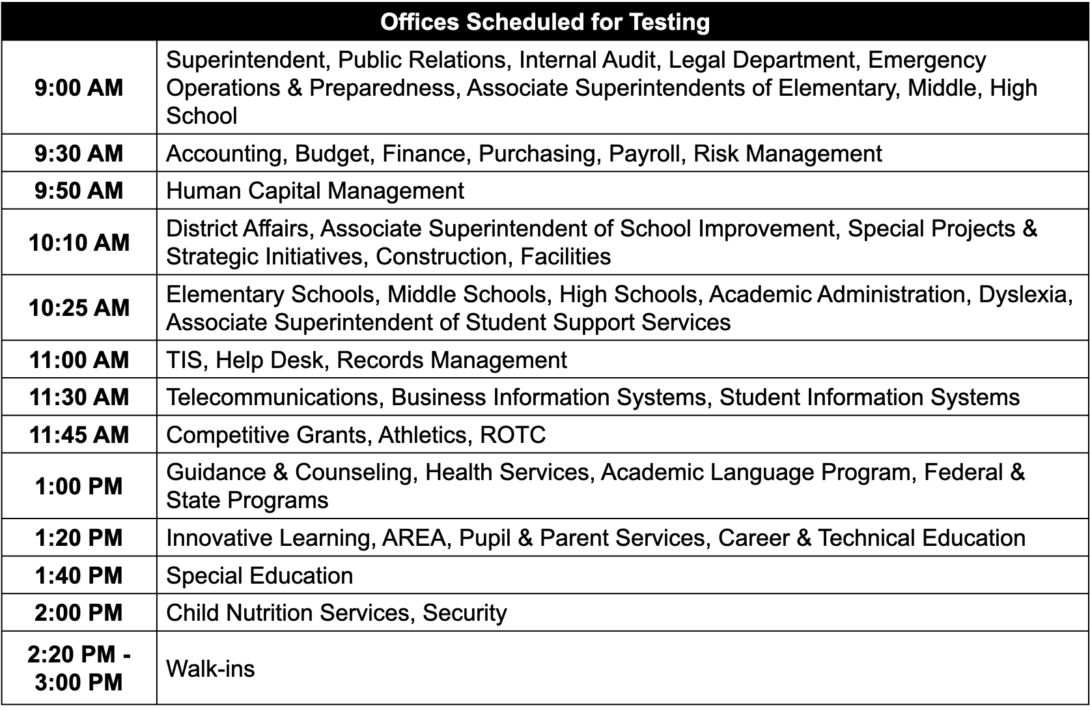

***Please do not reply to this email. This mailbox is not monitored and you will not receive a response.***  
  
Outlook Email Administration    
Ysleta Independent School District   
9600 Sims Dr.   
El Paso, TX. 79925

Ysleta Independent School District does not discriminate on the basis of race, color, national origin, religion, sex, disability, genetic information, or age in its programs, activities, or employment. El Distrito escolar de Ysleta no discrimina en base a raza, color, nacionalidad, religión, sexo, discapacidad, la información genética, y/o edad, en sus programas, actividades, o empleo.